<https://www.youtube.com/watch?v=g9c66TUylZ4&list=PLblh5JKOoLUICTaGLRoHQDuF_7q2GfuJF&index=40>



Today we're going to talk about regression trees and they're gonna be clearly explained.

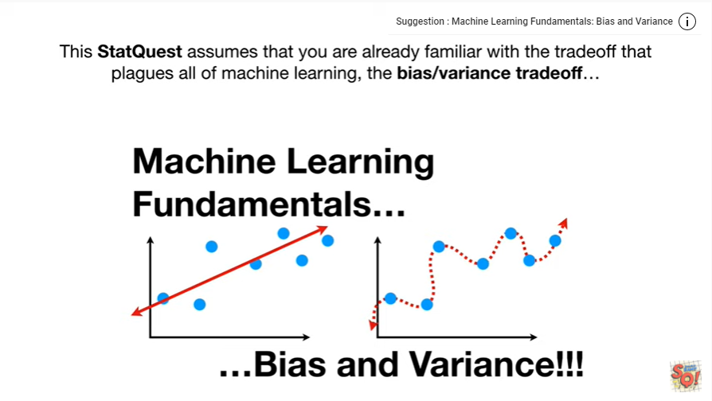

This stat quest assumes you are already familiar with the trade-off that plagues all of machine learning the bias-variance tradeoff

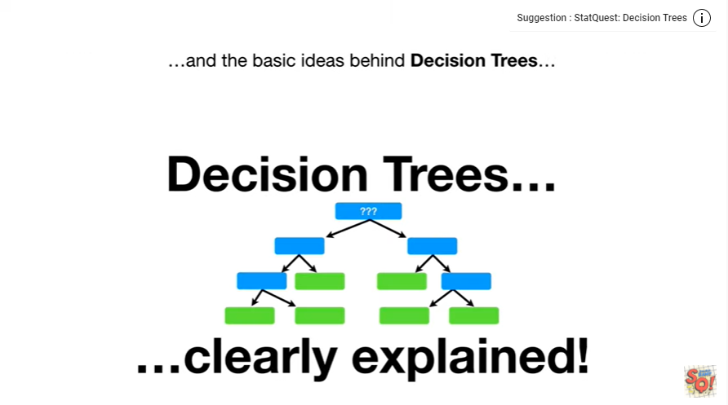

and the basic ideas behind decision trees

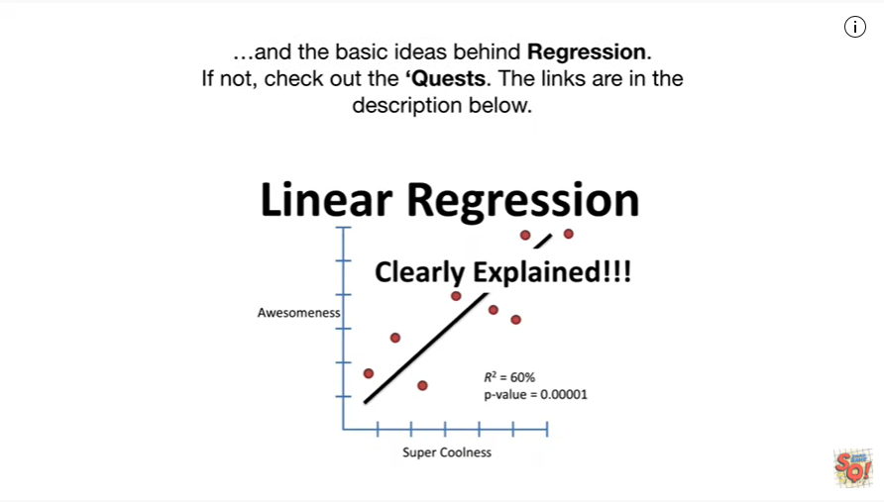

and the basic ideas behind regression.

If not check out the quests.

The links are in the description below.

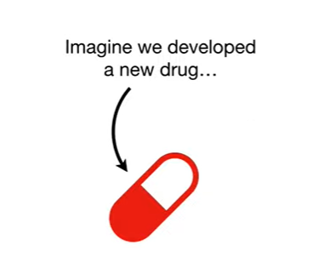

Now imagine we developed a new drug

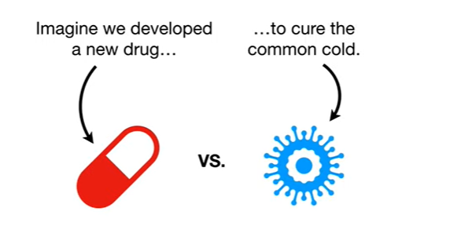

to cure the common cold.

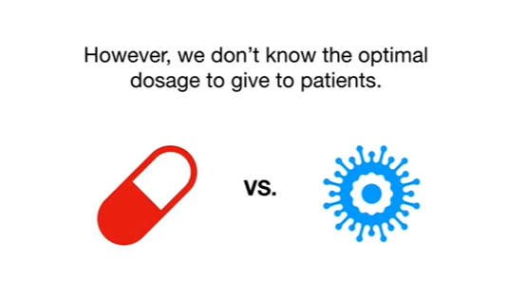

However, we don't know the optimal dosage to give patients.

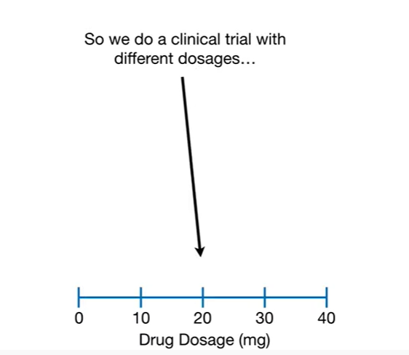

So we do a clinical trial with different dosages

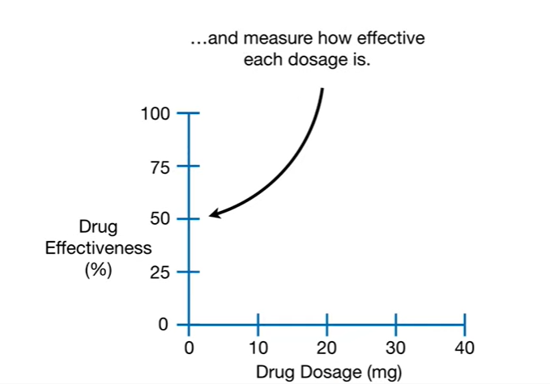

and measure how effective each dosage is.

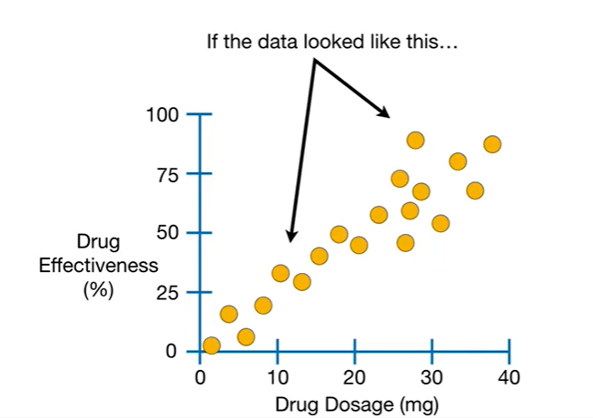

If the data looked like this

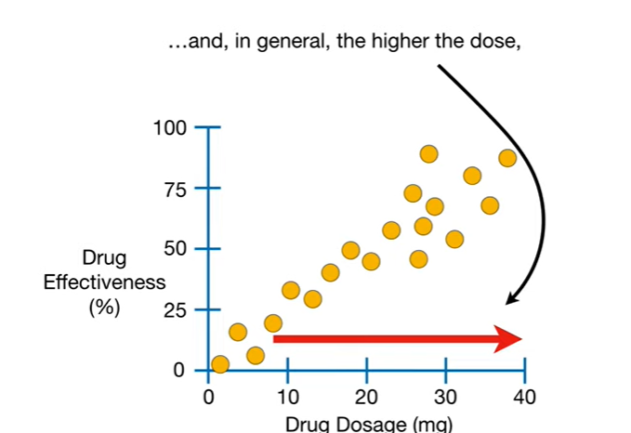

And, in genera,l the higher the dose, the more effective the drug

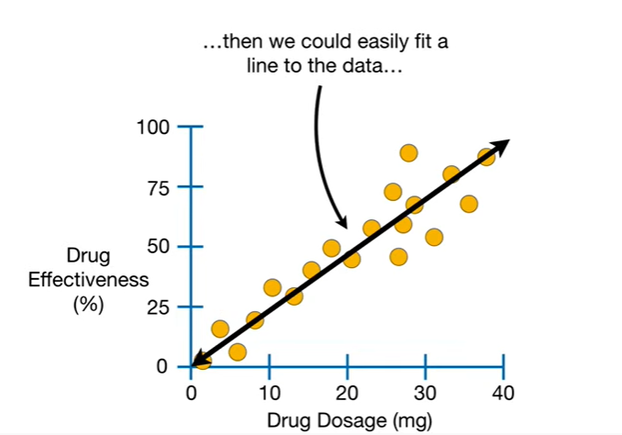

then we could easily fit a line to the data

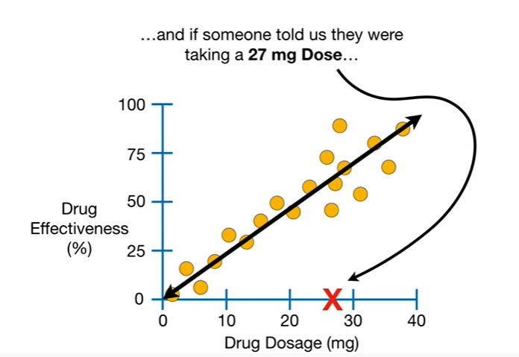

and if someone told us they were taking a 27 milligram dose

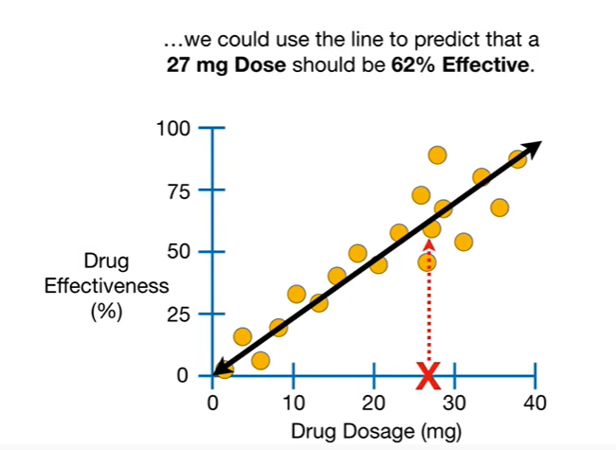

we could use the line to predict that a 27 milligram dose

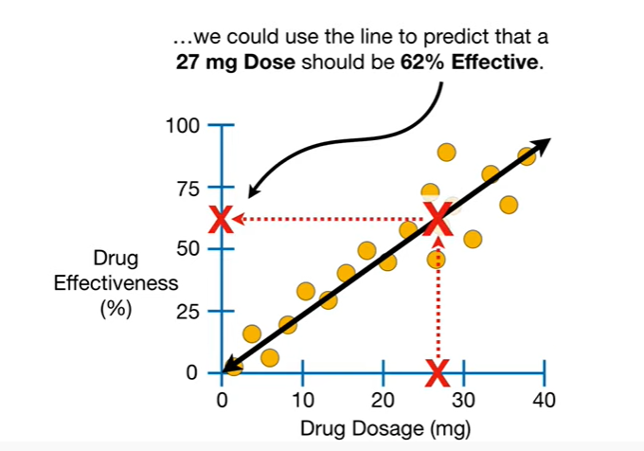

should be 62% effective.

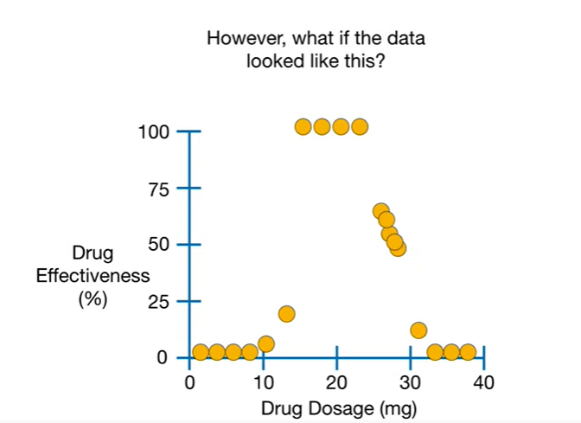

However what if the data looked like this ?

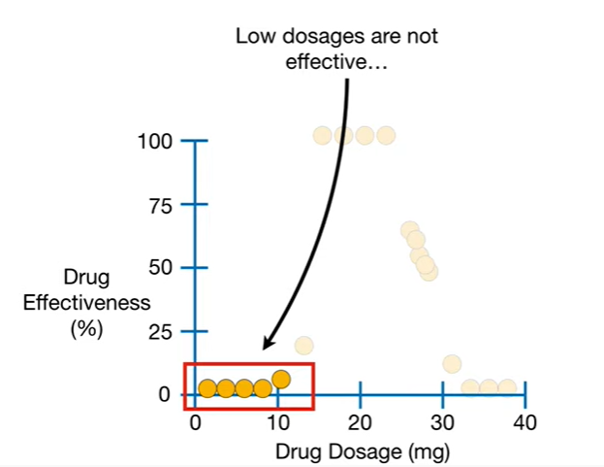

Low dosages are not effective

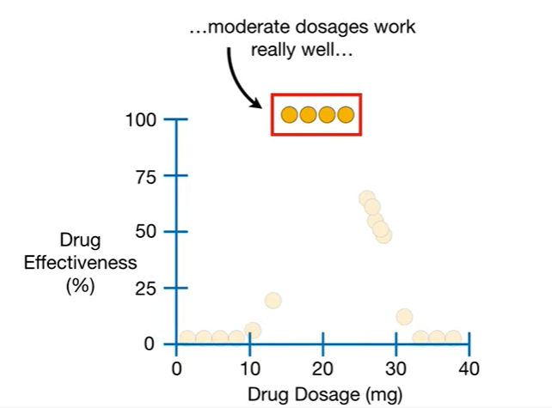

moderate dosages work really well

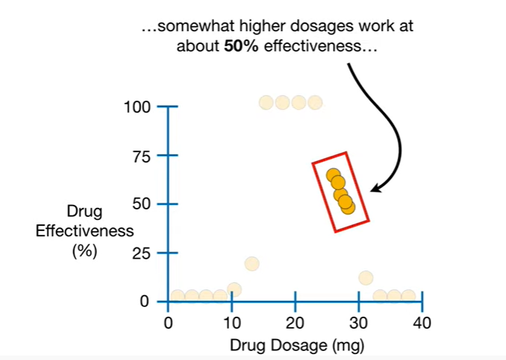

somewhat higher dosages work at about 50% effectiveness

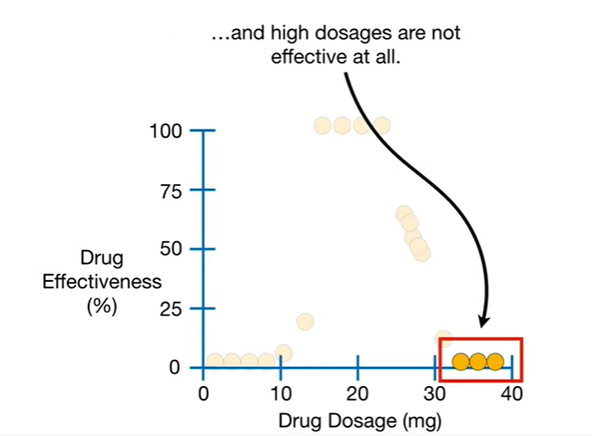

and high dosages are not effective at all.

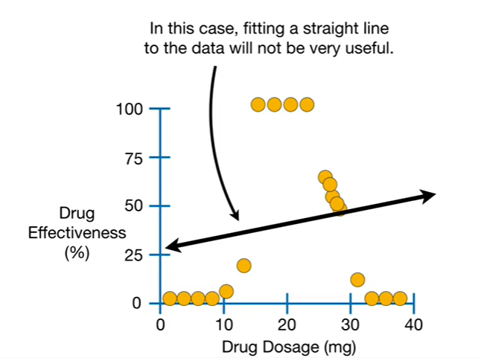

In this case fitting a straight line to the data will not be very useful.

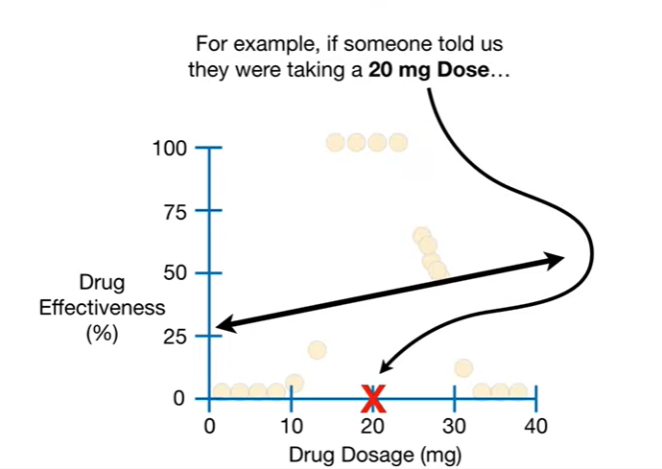

For example if someone told us they were taking a 20 milligram dose

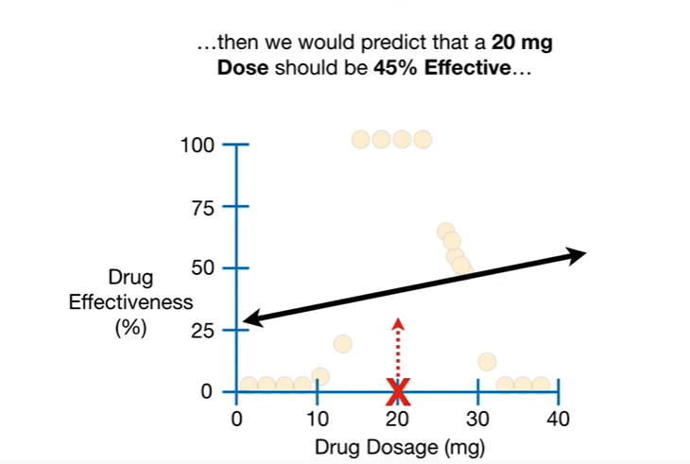

then we would predict that a 20 milligram dose

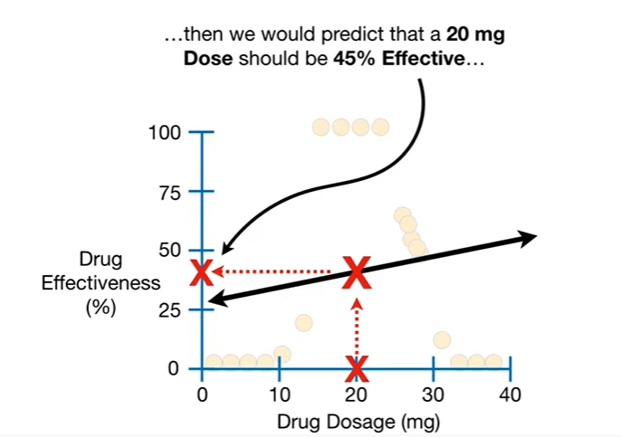

should be 45% effective

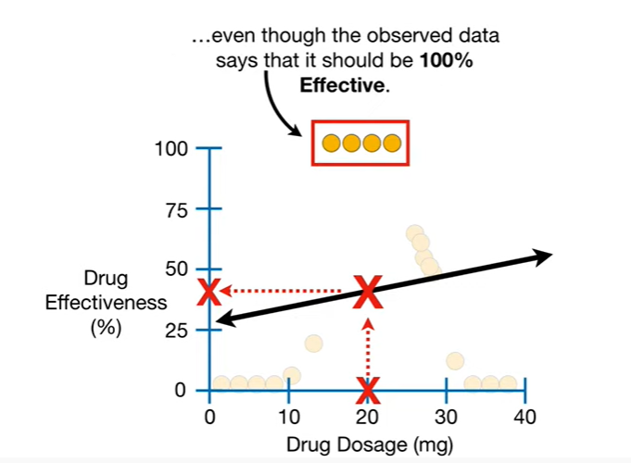

even though the observed data says it should be 100% effective.

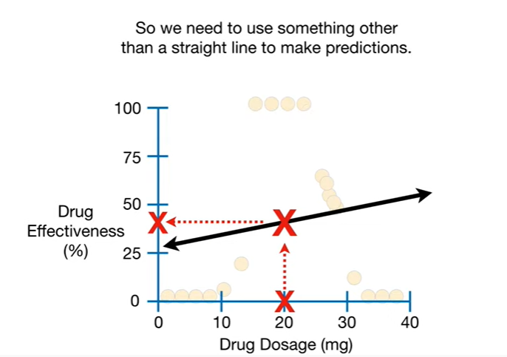

So we need to use something other than a straight line to make predictions.

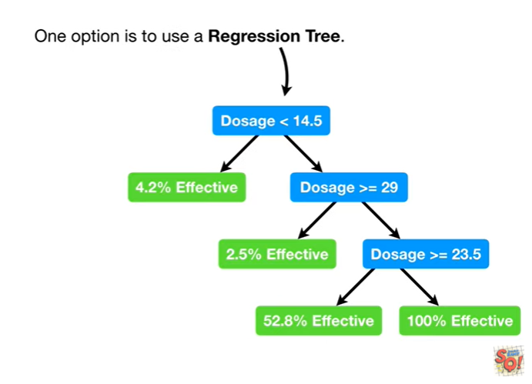

One option is to use a regression tree.

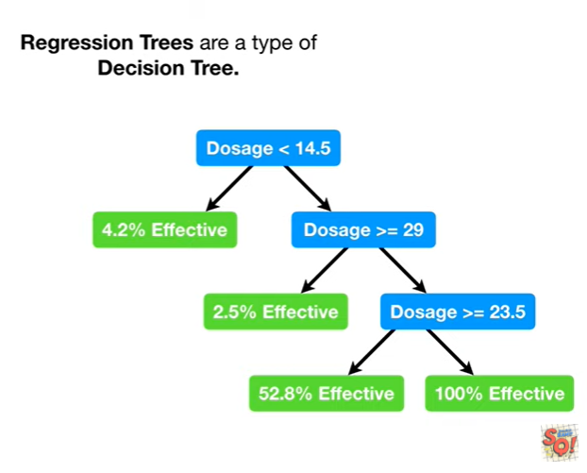

Regression trees are a type of decision tree.

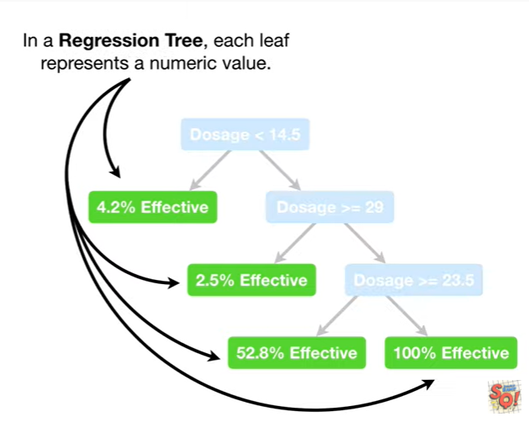

In a regression tree each leaf represents a numeric value.

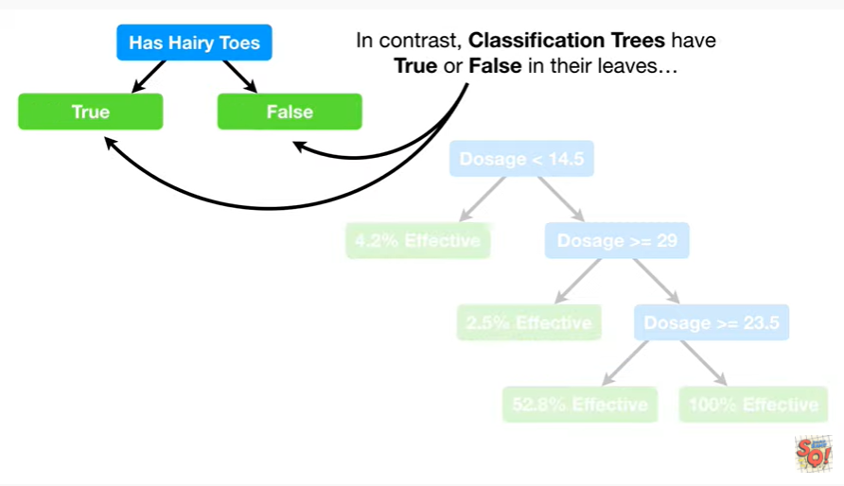

In contrast, classification trees have true or false in their leaves

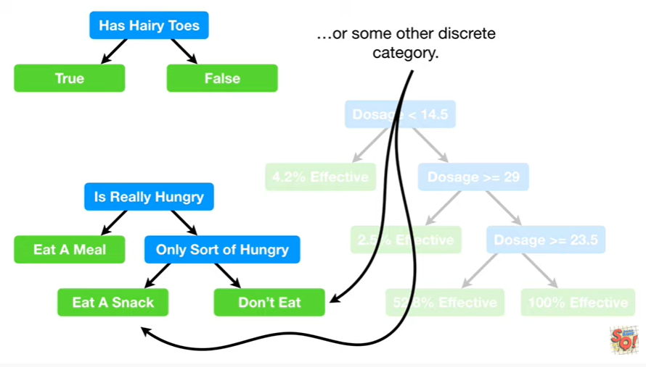

or some other discrete category.

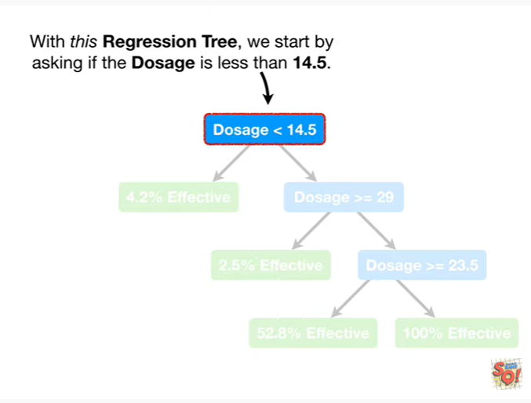

With this regression tree we start by asking if the dosage is less than 14.5.

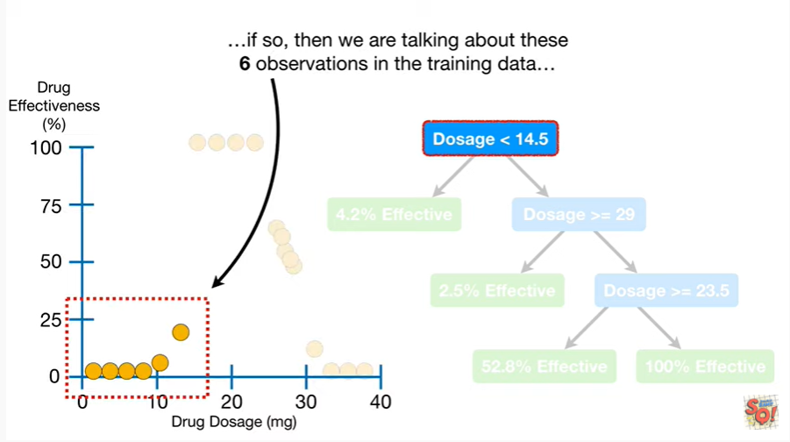

If so then we are talking about these six observations in the training data

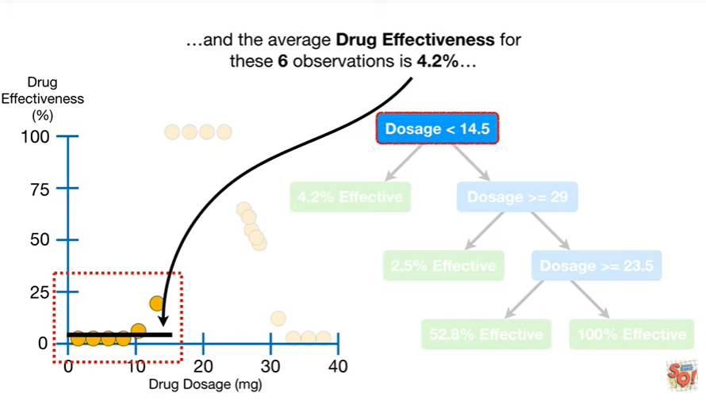

and the average drug effectiveness for these six observations is 4.2 percent

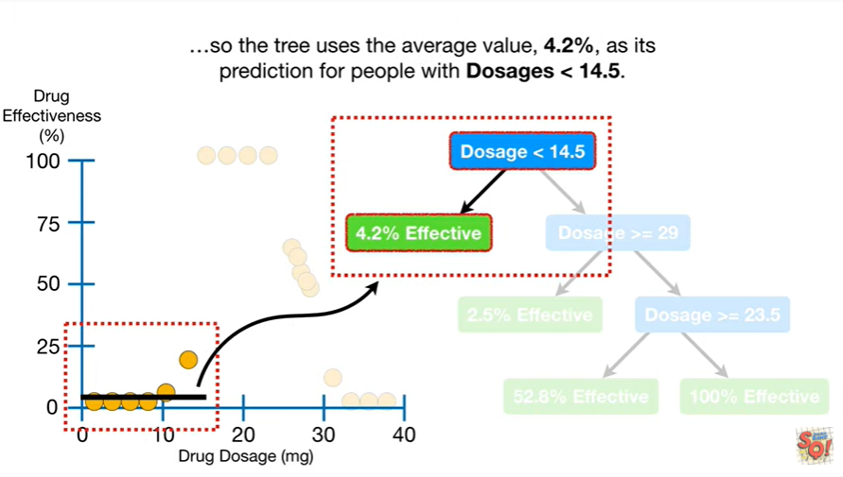

so the tree uses the average value, for point two percent, as its prediction for people with dosages less than fourteen point five.

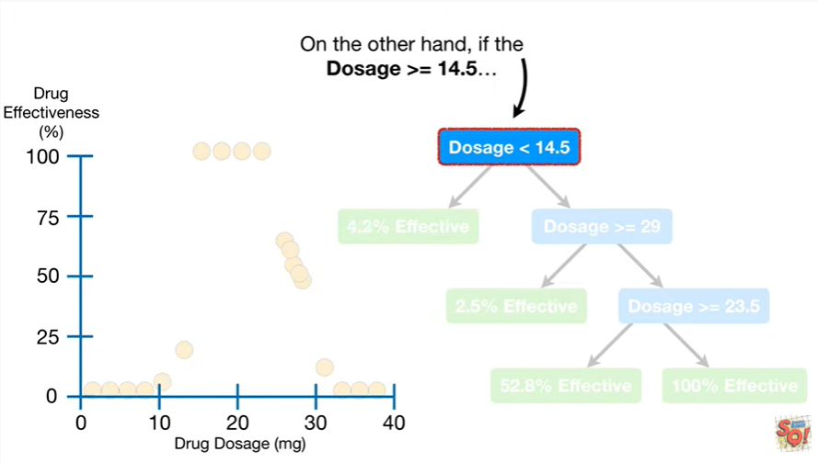

On the other hand if the dosage is greater than or equal to 14.5

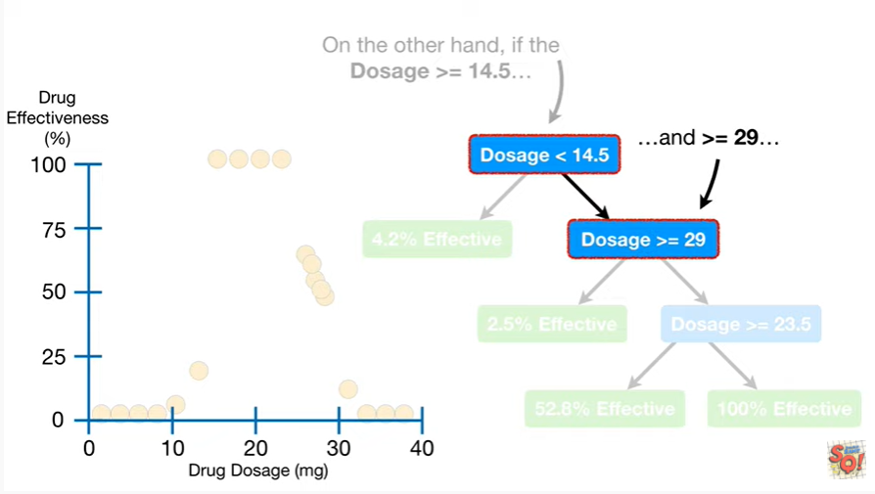

and greater than or equal to 29

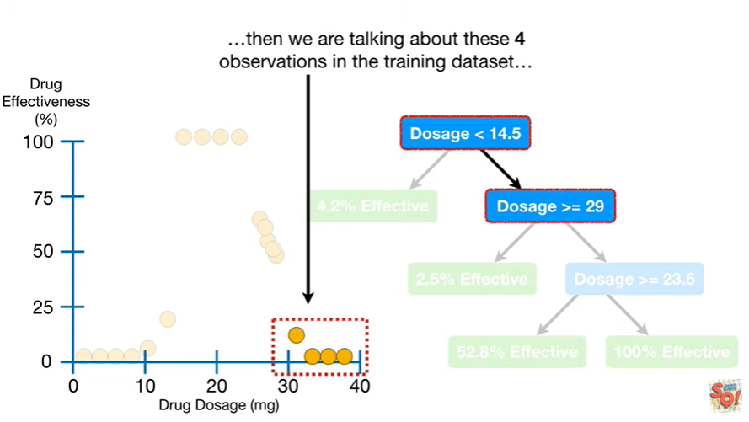

then we are talking about these four observations in the training data set

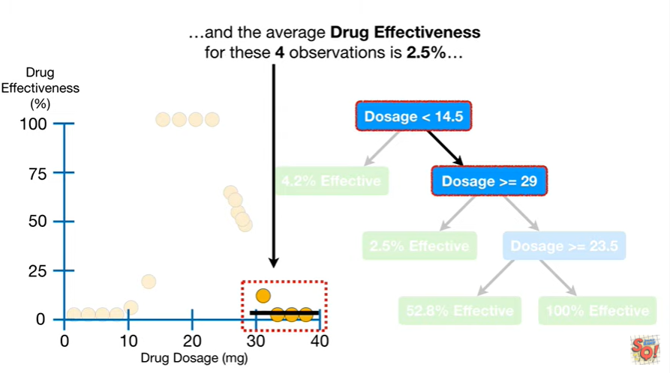

and the average drug effectiveness for these four observations is 2.5 percent

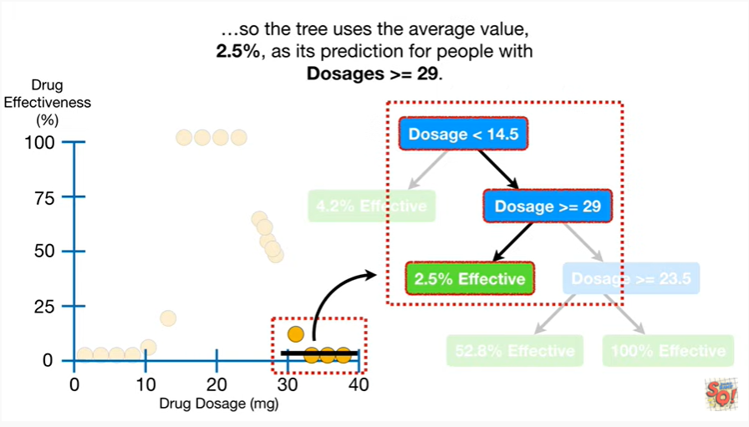

so the tree uses the average value 2.5 percent as its prediction for people with dosages greater than or equal to 29.

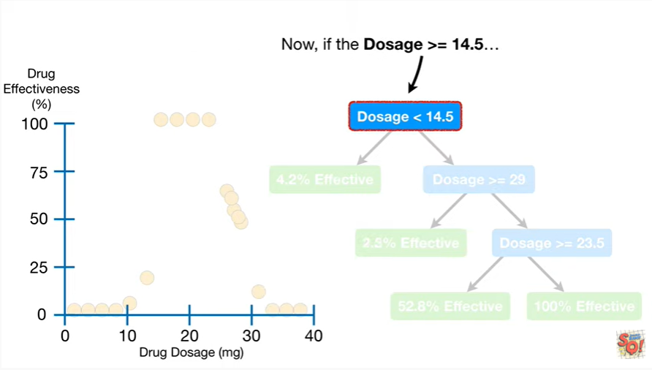

Now if the dosage is greater than or equal to 14.5

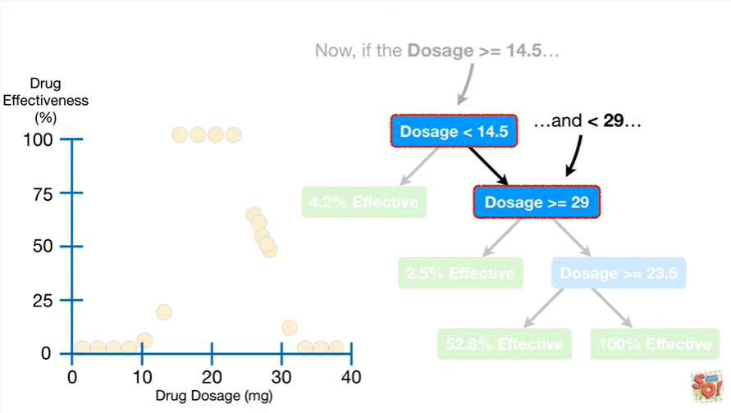

and less than 29

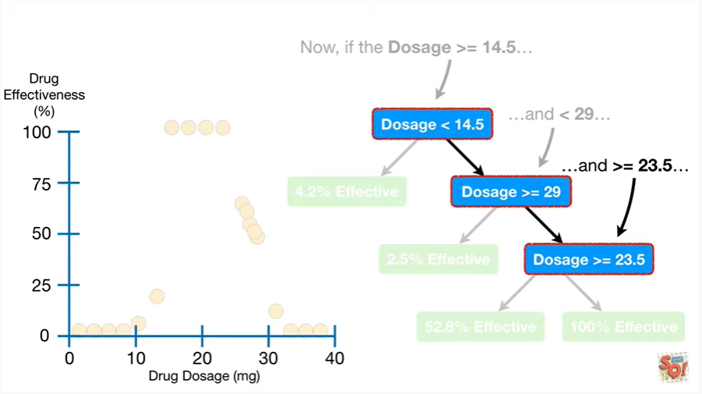

and greater than or equal to 23 point 5

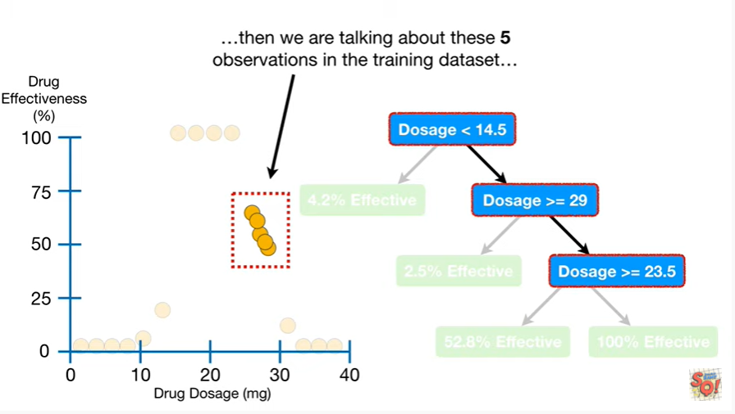

then we are talking about these 5 observations in the training data set

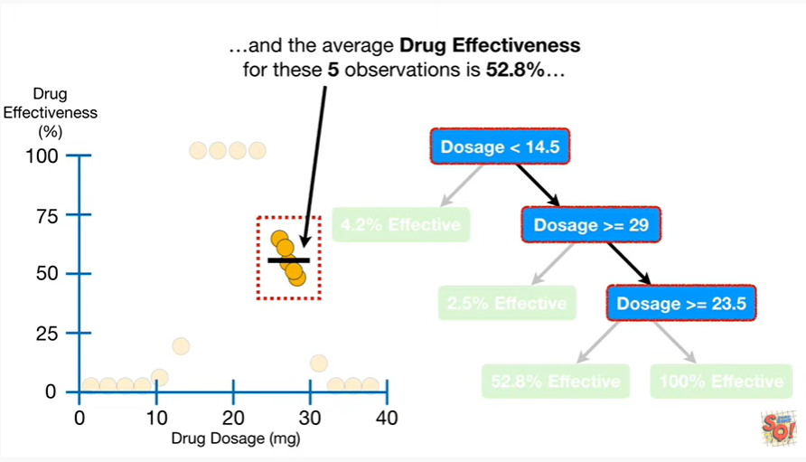

and the average drug effectiveness for these 5 observations is 52.8%

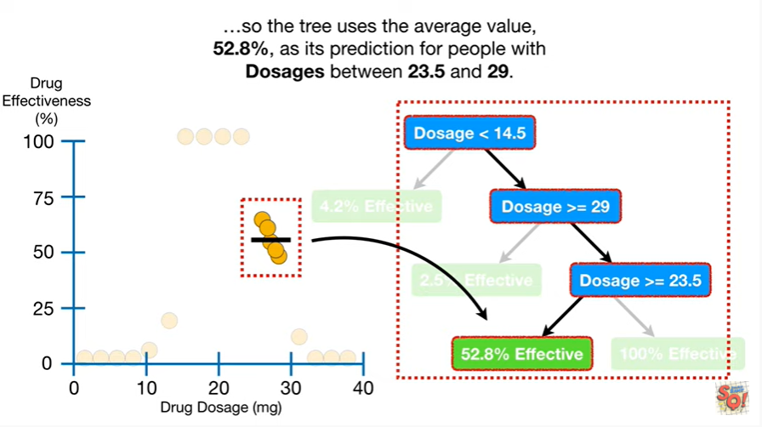

so the tree uses the average value 52.8% as its prediction for people with dosages between 23 point five and 29.

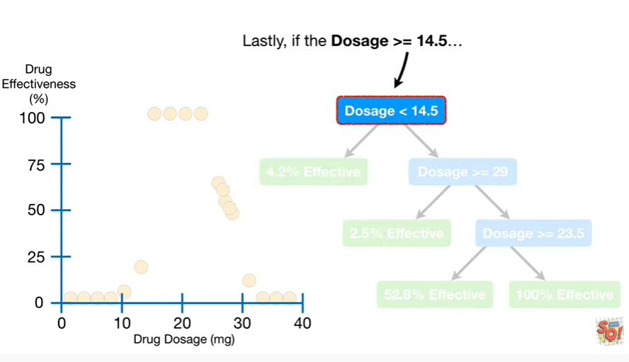

Lastly if the dosage is greater than or equal to 14.5

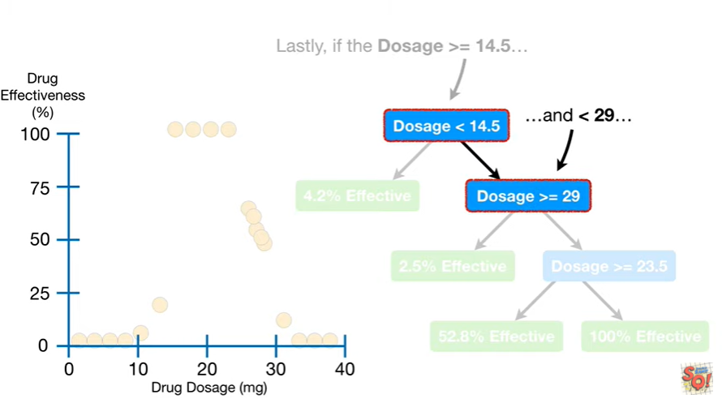

and less than 29

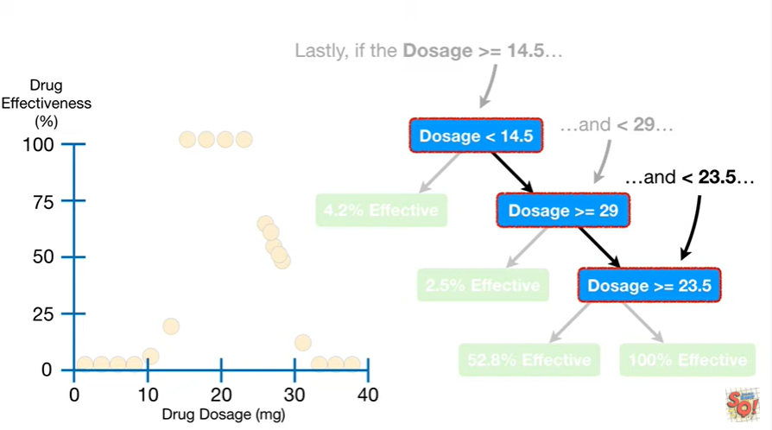

and less than 23 point 5

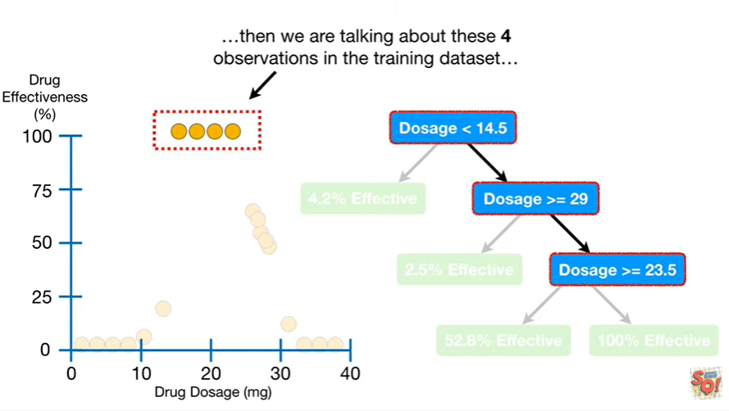

then we are talking about these four observations in the training data set

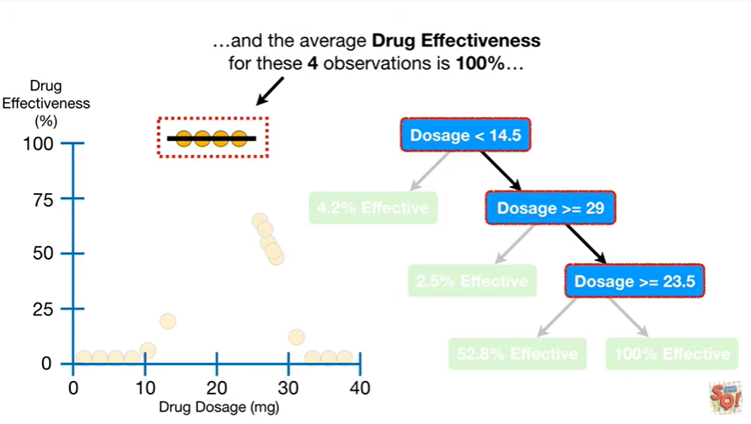

and the average drug effectiveness for these four observations is 100%

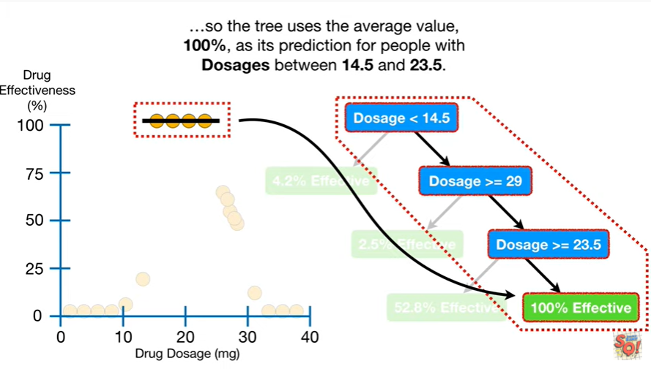

so the tree uses the average value 100% as its prediction for people with dosages between 14.5 and 23.5.

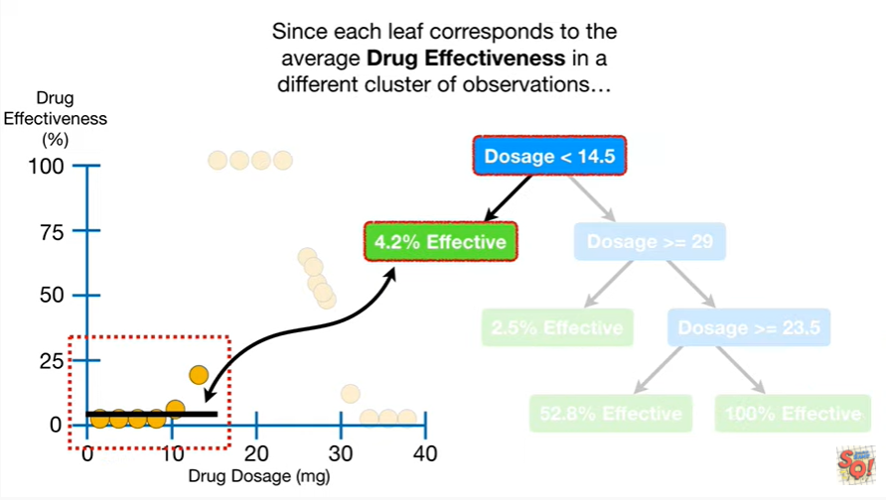

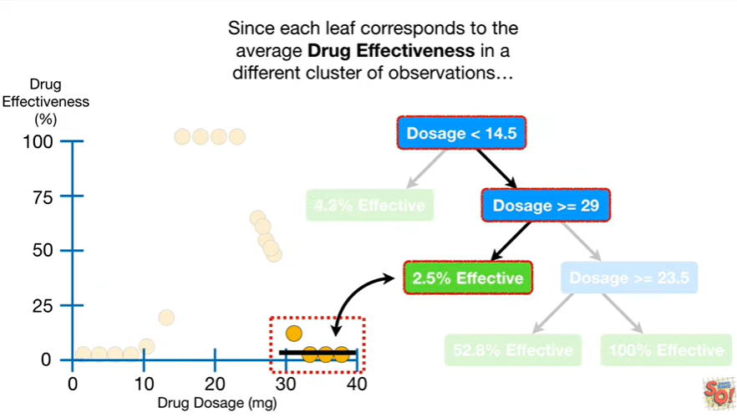

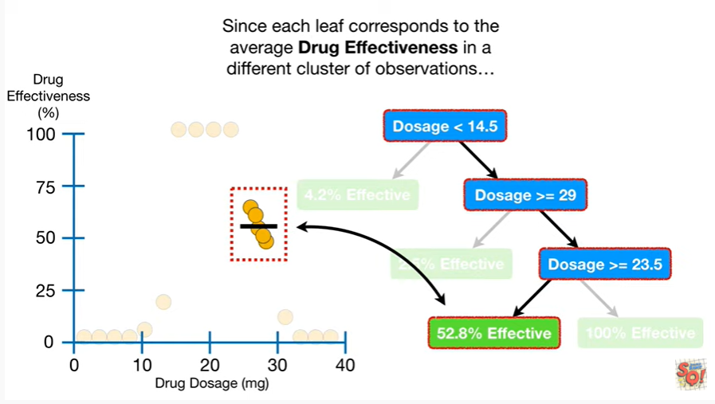

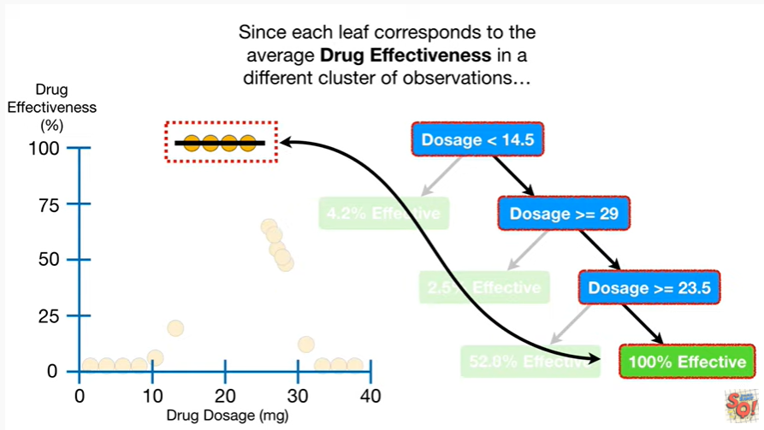

Since each leaf corresponds to the average drug effectiveness in a different cluster of observations

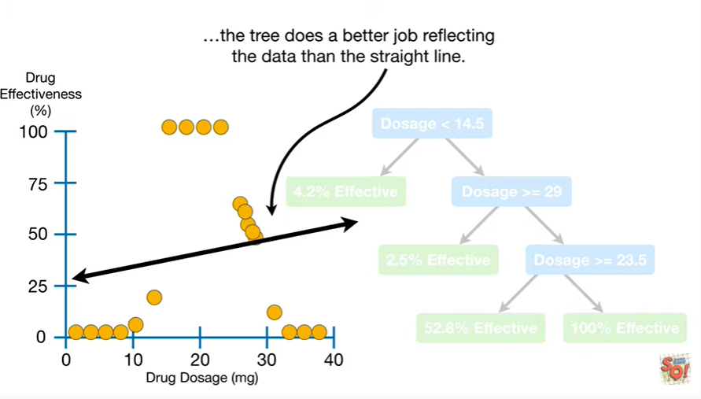

the tree does a better job reflecting the data than the straight line.

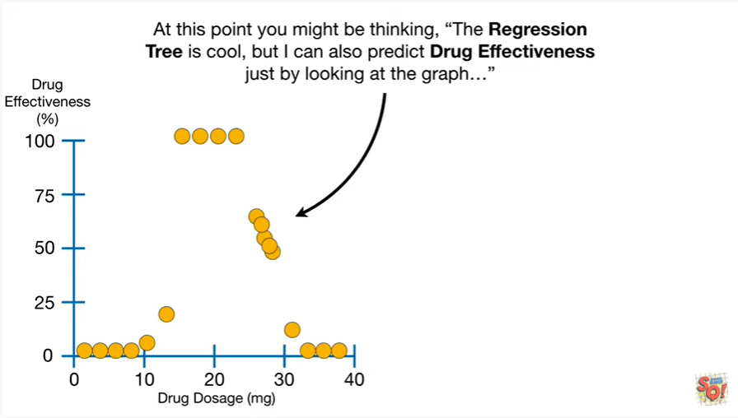

At this point you might be thinking, the regression tree is cool, but I can also predict drug effectiveness just by looking at the graph.

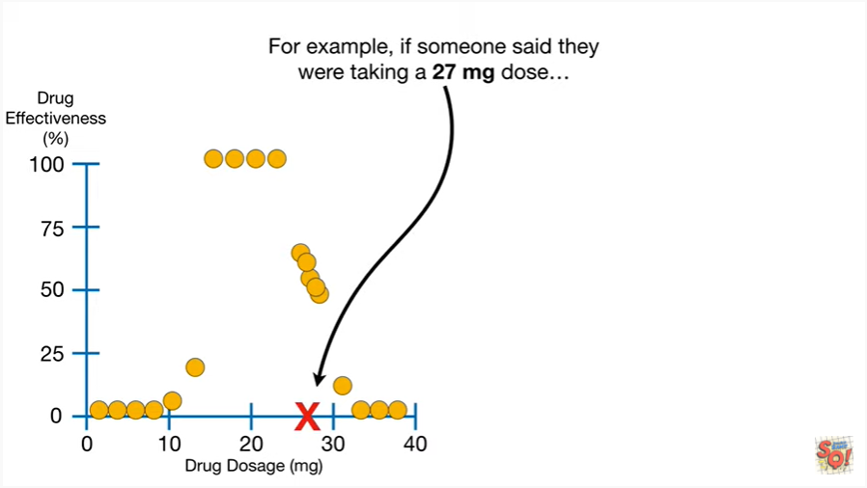

For example if someone said they were taking a 27 milligram dose

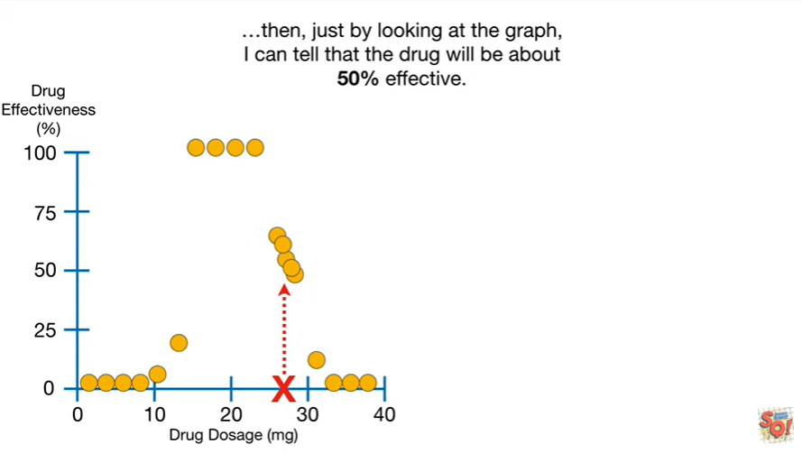

Then, just by looking at the graph, I can tell that the drug will be about 50% effective.

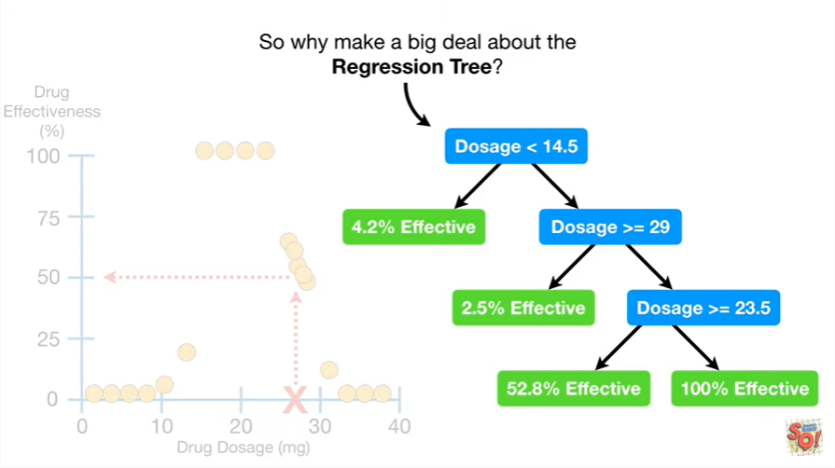

So why make a big deal about the regression tree ?

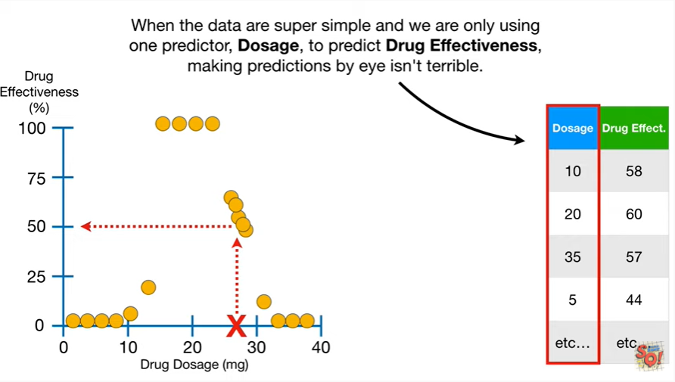

When the data are super simple and we are only using one predictor, dosage, to predict drug effectiveness, making predictions by eye isn't terrible.

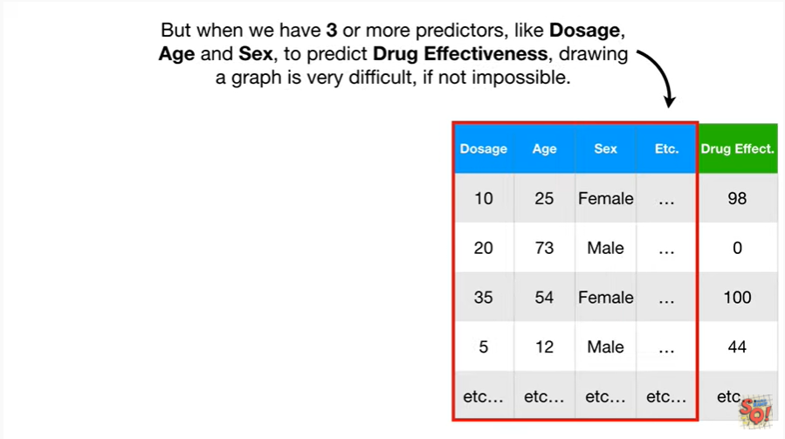

But when we have three or more predictors, like dosage, age and sex, to predict drug effectiveness, drawing a graph is very difficult, if not impossible.

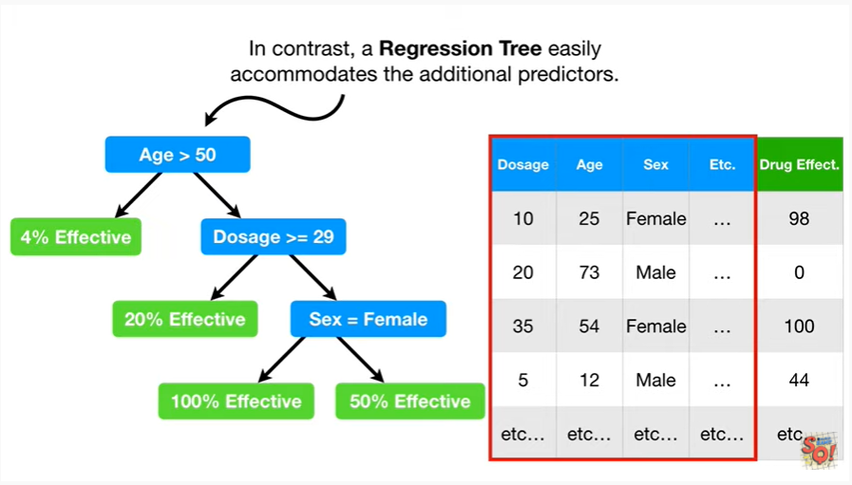

In contrast, a regression tree easily accommodates the additional predictors.

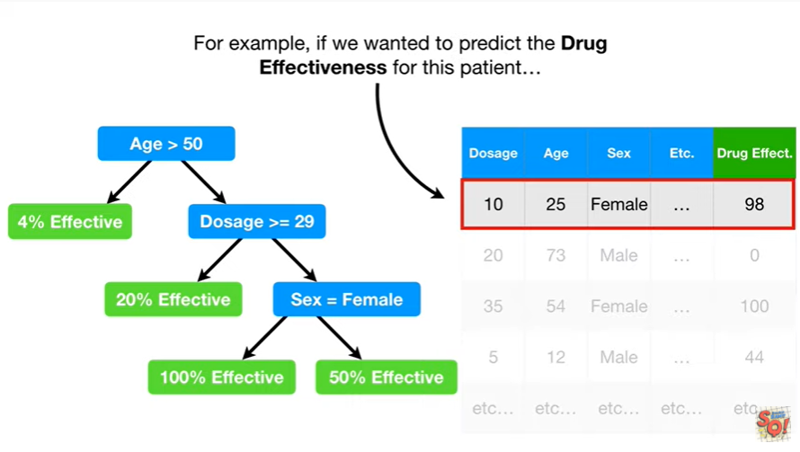

For example if we wanted to predict the drug effectiveness for this patient

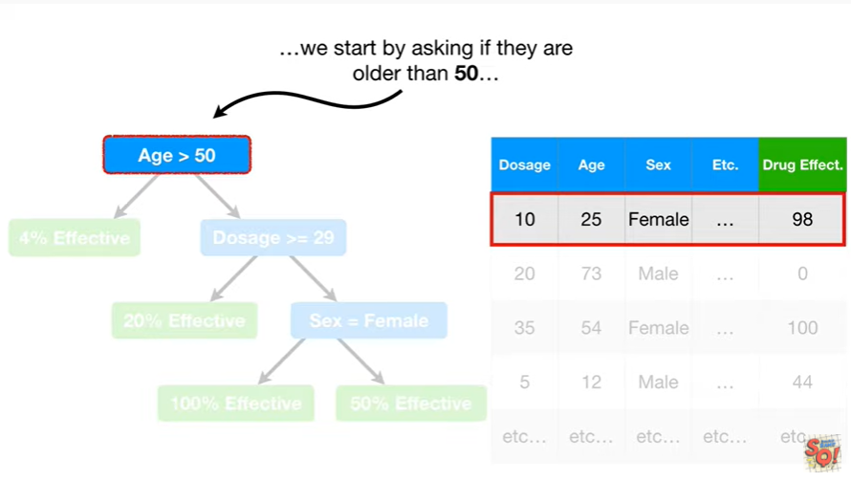

we would start by asking if they are older than 50

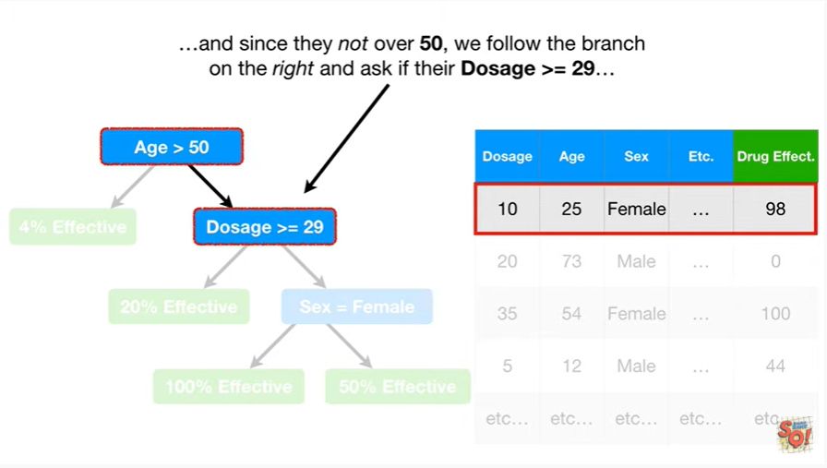

and since they are not over 50, we follow the branch on the right and ask if their dosage is greater than or equal to 29

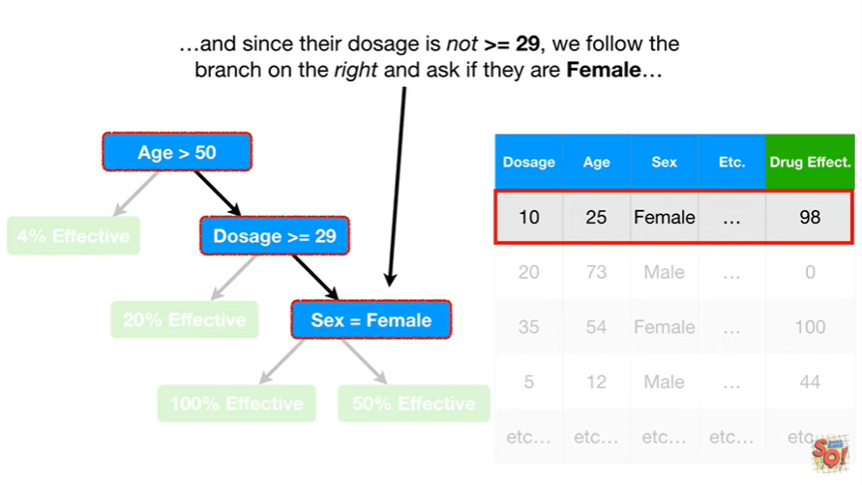

and since their dosage is not greater than or equal to 29, we follow the branch on the right and ask if they are female

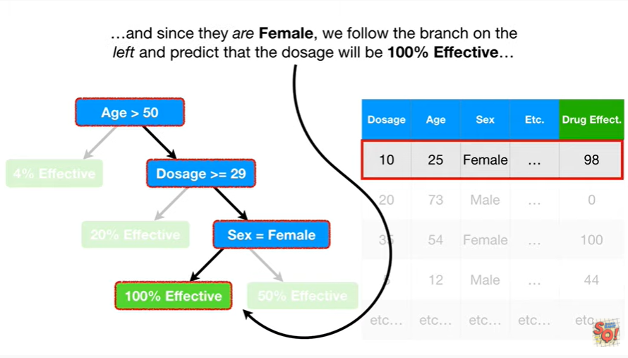and since they are female, we follow the branch on the left and predict that the dosage will be 100% effective

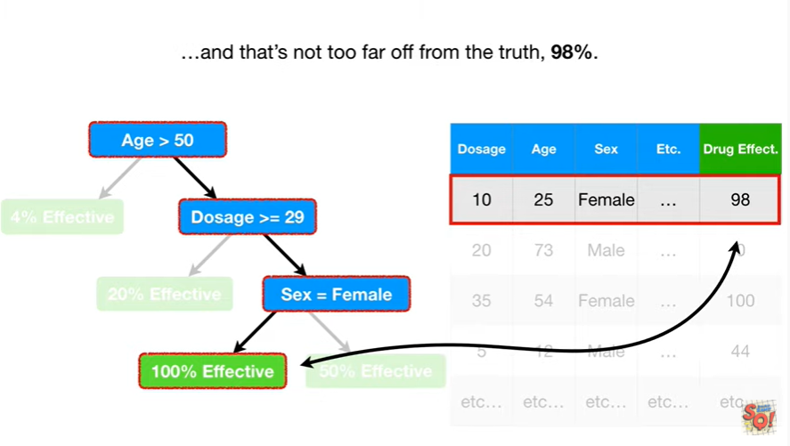

and that's not too far off from the truth 98%.

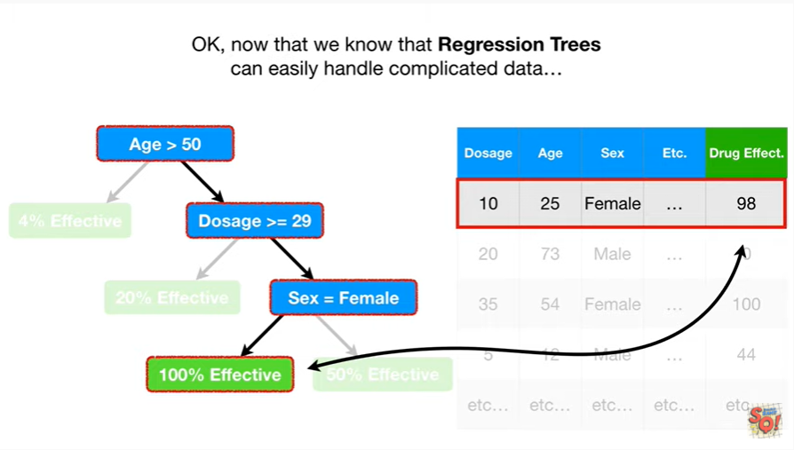

Okay, now that we know that regression trees can easily handle complicated data

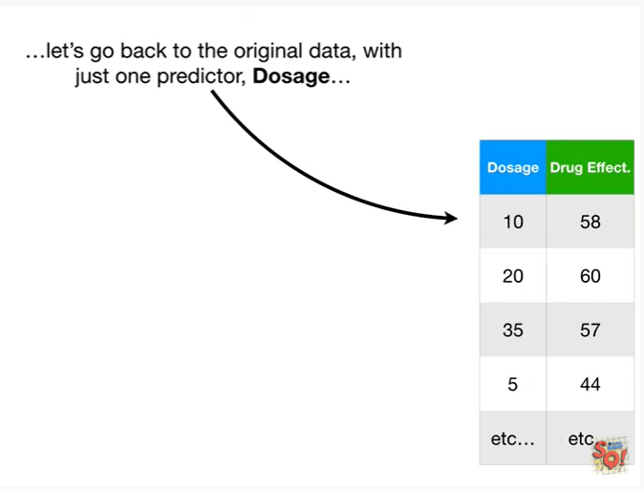

let's go back to the original data, with just one predictor dosage

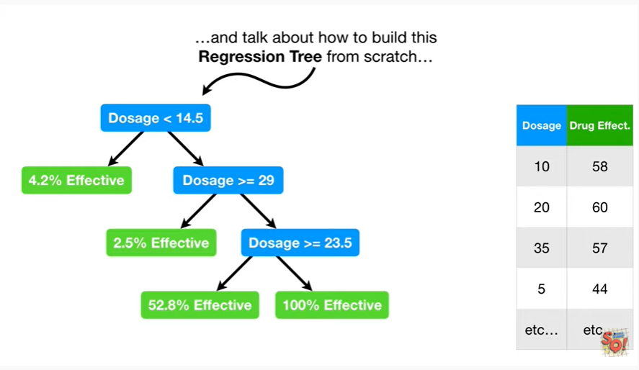

and talk about how to build this regression tree from scratch

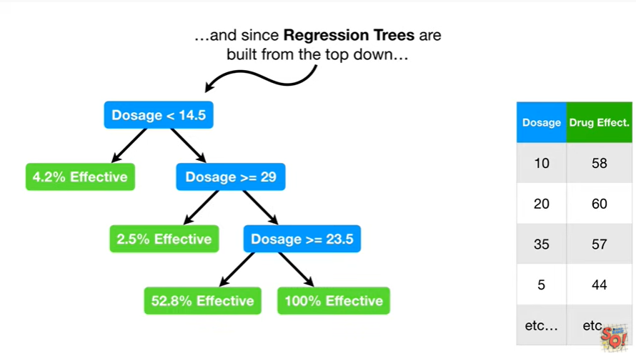

and since regression trees are built from the top down

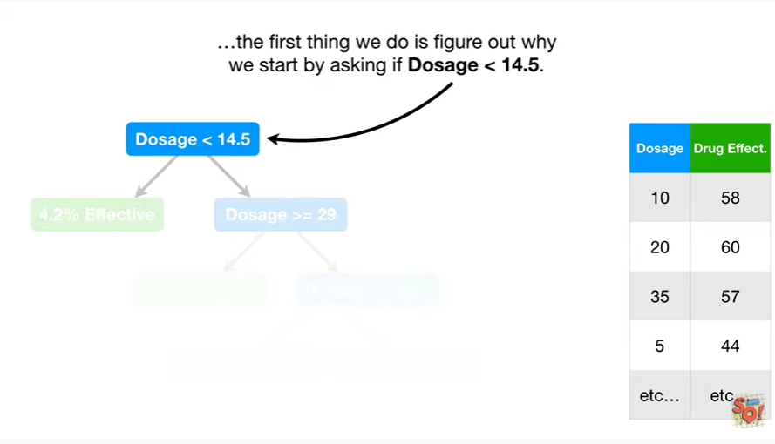

the first thing we do is figure out why we start by asking if dosage is less than 14.5.

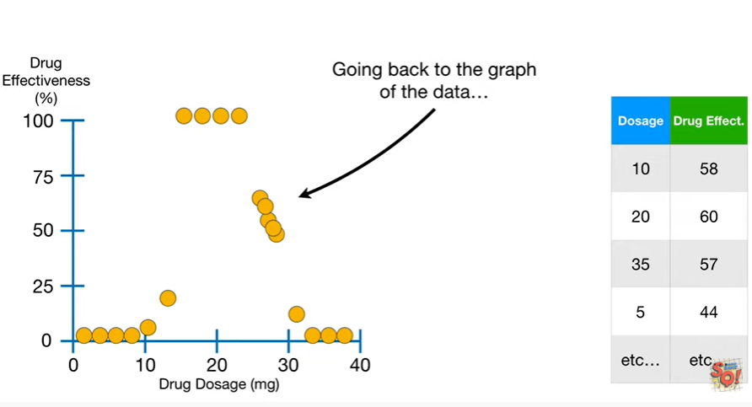

Going back to the graph of the data

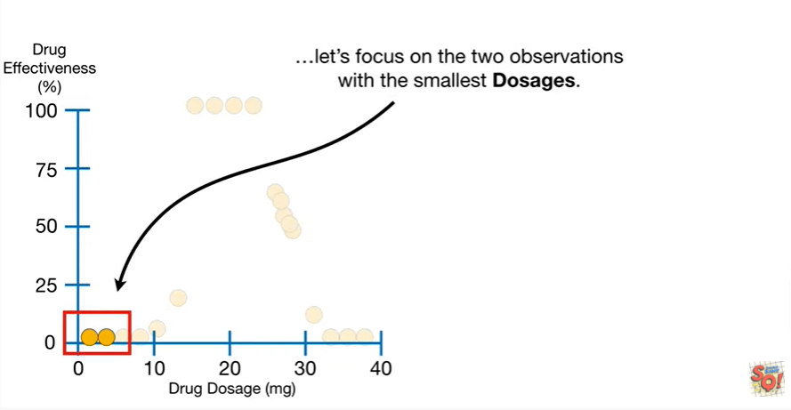

let's focus on the two observations with the smallest dosages.

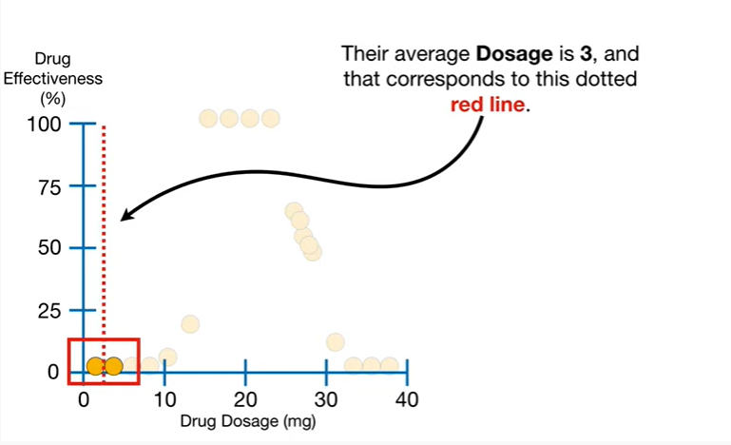

Their average dosage is three and that corresponds to this dotted red line.

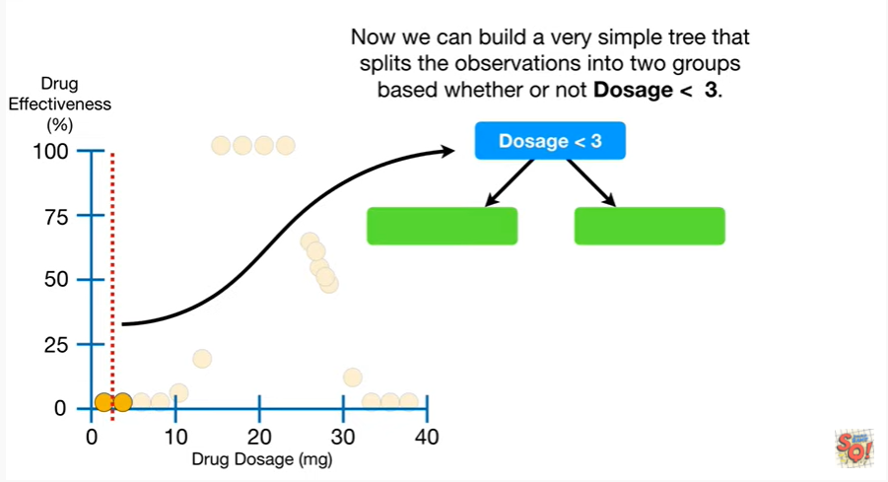

Now we can build a very simple tree that splits the observations into two groups based on whether or not dosage is less than three.

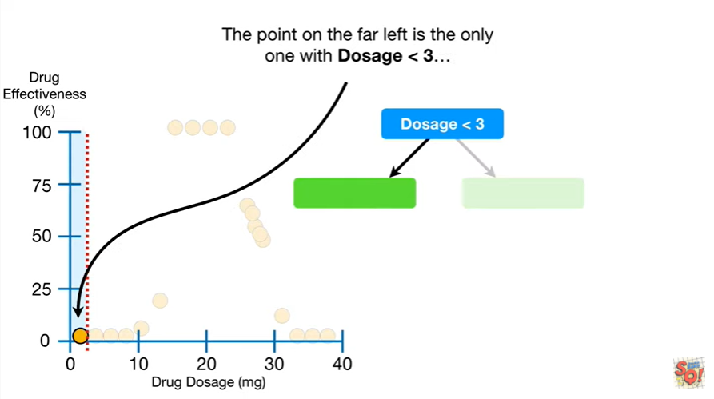

The point on the far left is the only one with dosage less than three

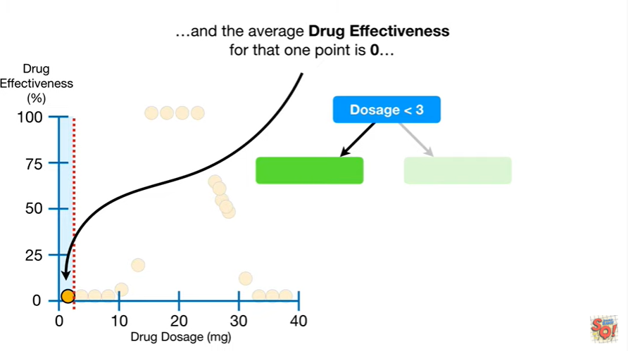

and the average drug effectiveness for that one point is zero

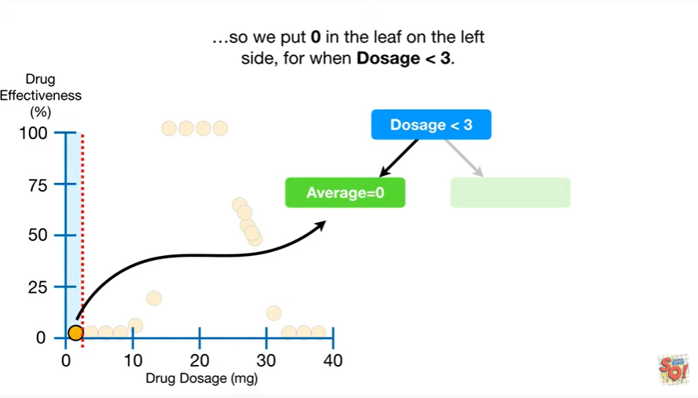

so we put zero in the leaf on the left side for when dosage is less than three.

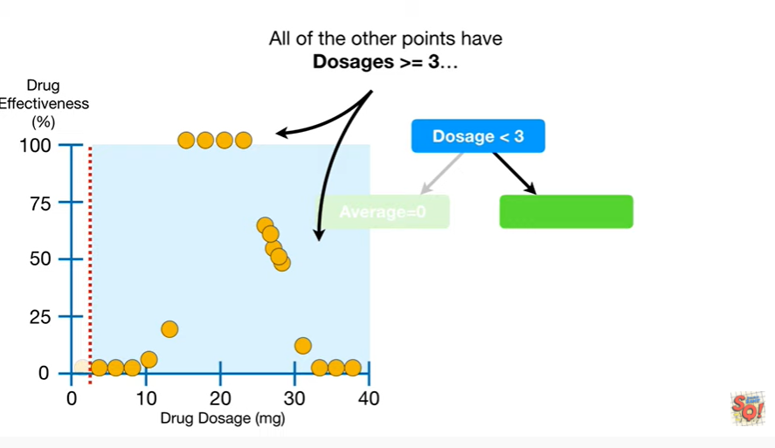

All of the other points have dosages greater than or equal to three

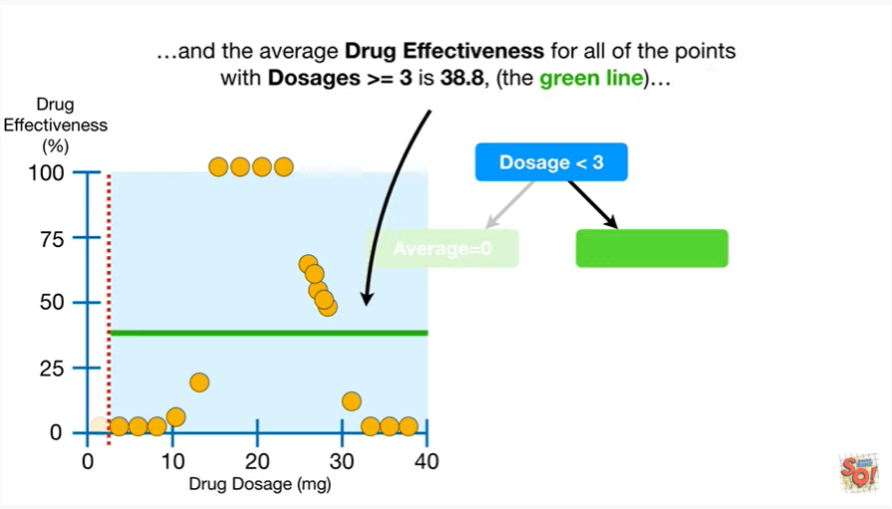

and the average drug effectiveness for all of the points with dosages greater than or equal to three is thirty eight point eight (the green line)

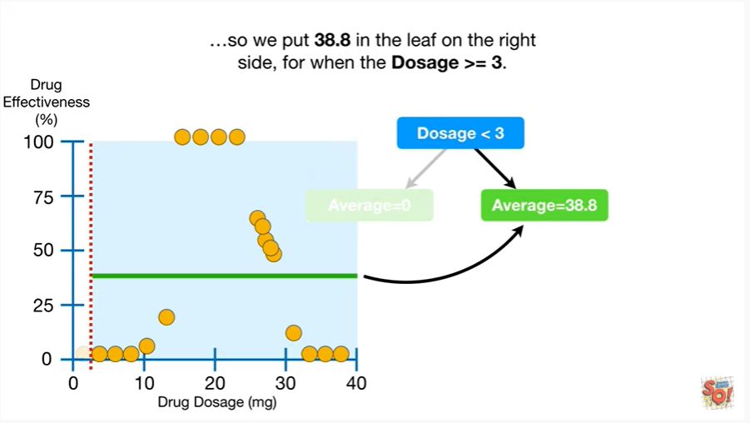

so we put 38.8 in the leaf on the right side for when dosage is greater than or equal to three.

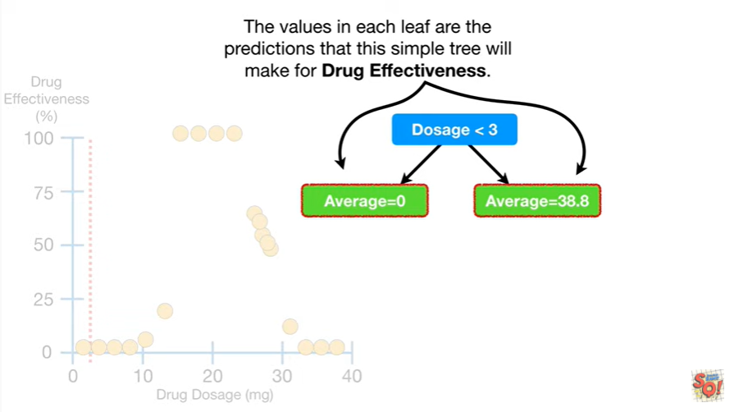

The values in each leaf are the predictions that this simple tree will make for drug effectiveness.

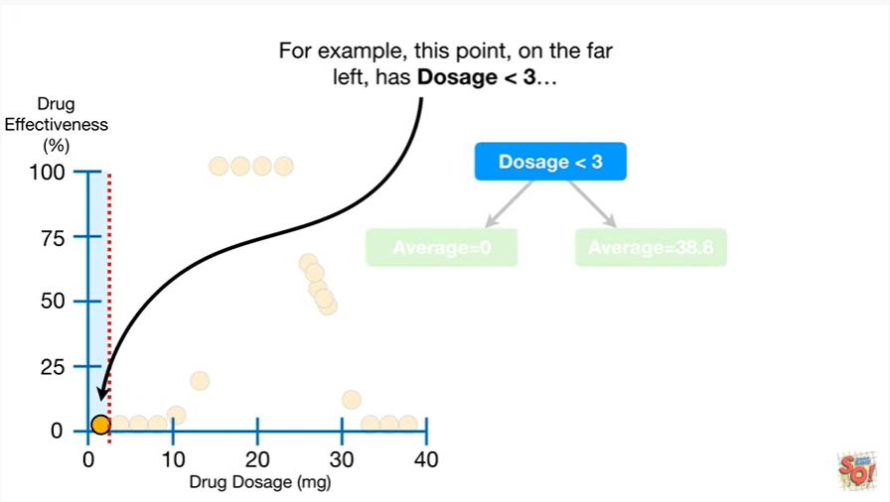

For example this point on the far left has dosage less than three

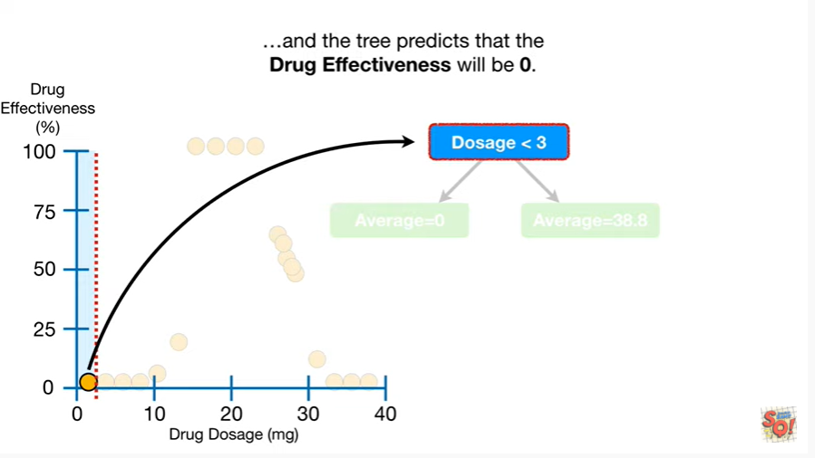

and the tree predicts that the drug effectiveness will be zero.

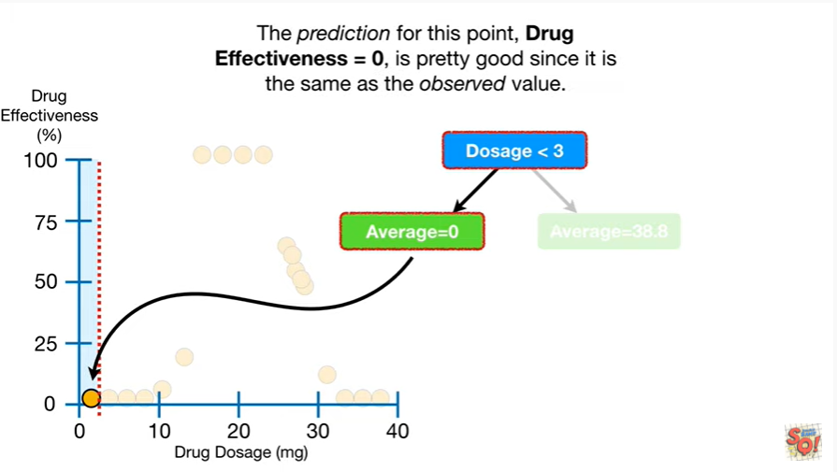

The prediction for this point, drug effectiveness equals zero, is pretty good since it is the same as the observed value.

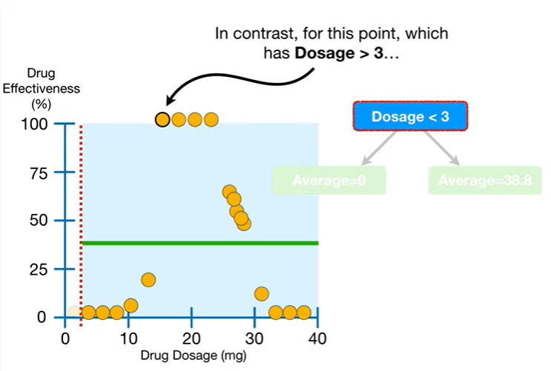

In contrast for this point which has dosage greater than three

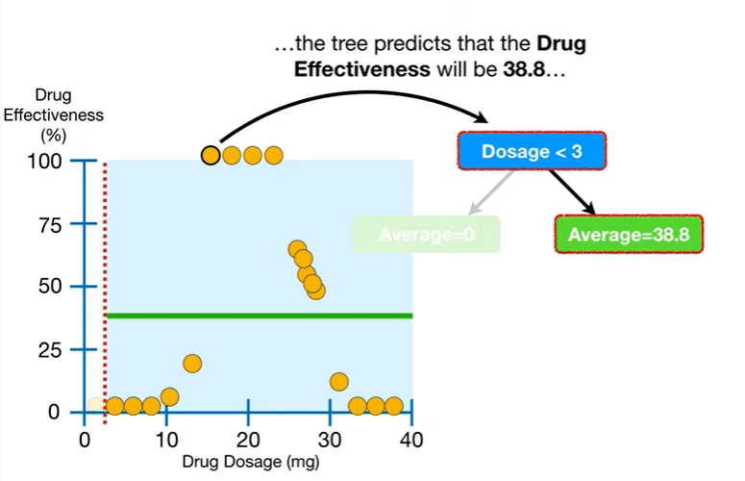

the tree predicts that the drug effectiveness will be 38.8

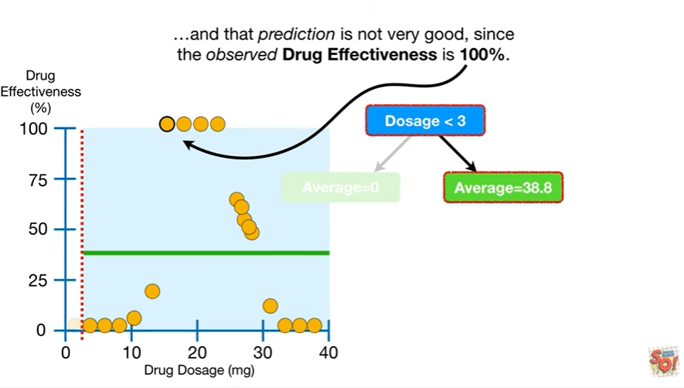

and that prediction is not very good since the observed drug effectiveness is 100%.

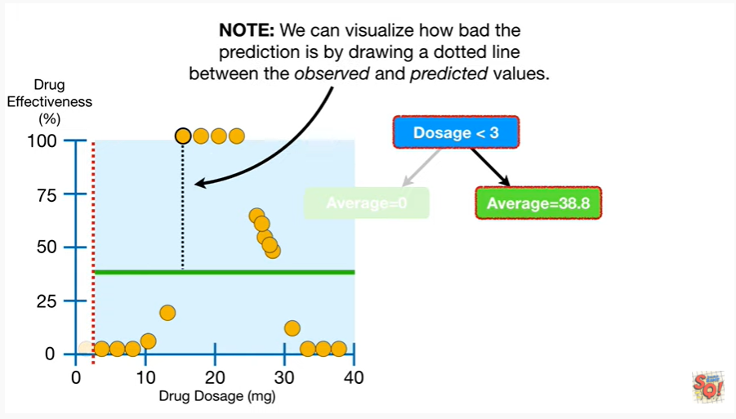

Note : we can visualize how bad the prediction is by drawing a dotted line between the observed and predicted values.

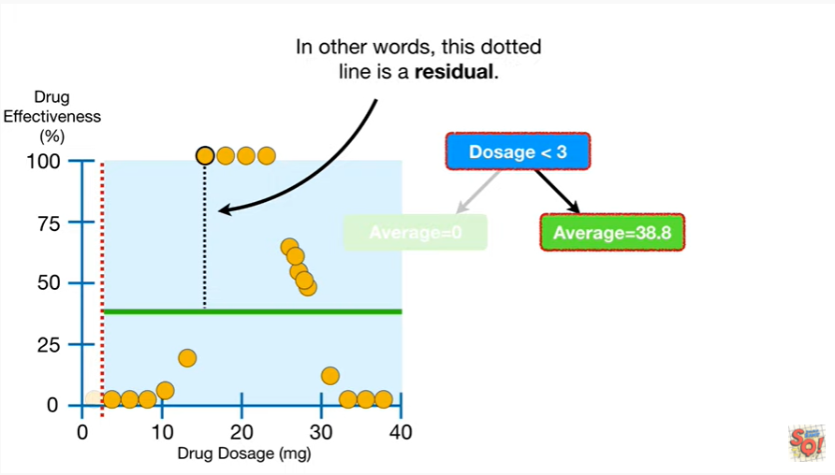

In other words, the dotted line is a residual.

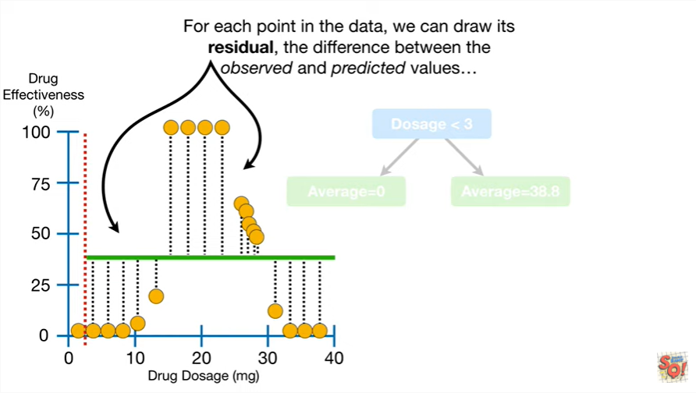

For each point in the data, we can draw its residual, the difference between the observed and predicted values

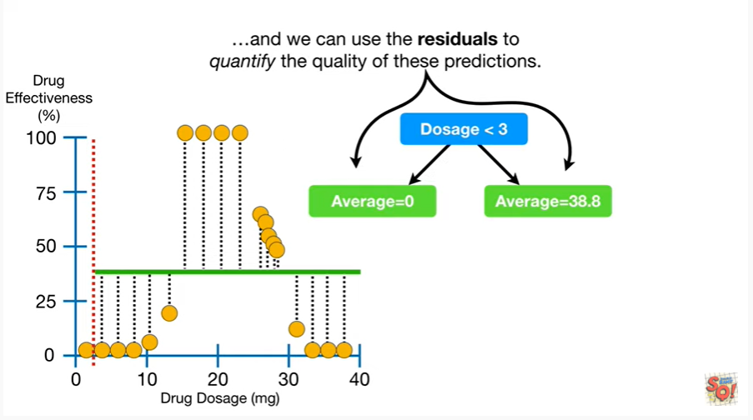

and we can use the residuals to quantify the quality of these predictions.

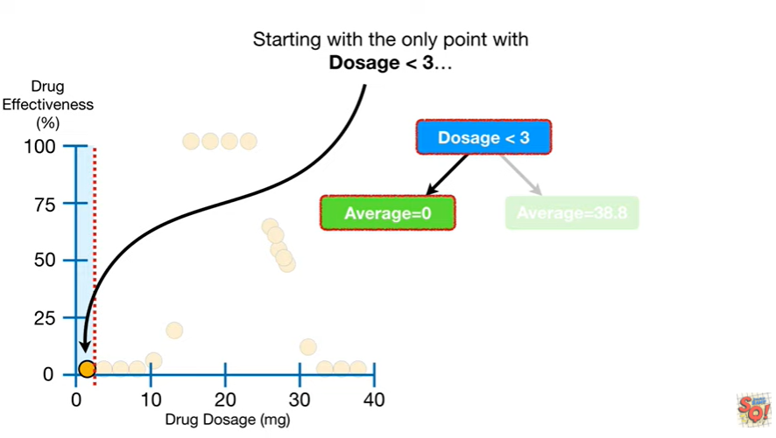

Starting with the only point with dosage less than three

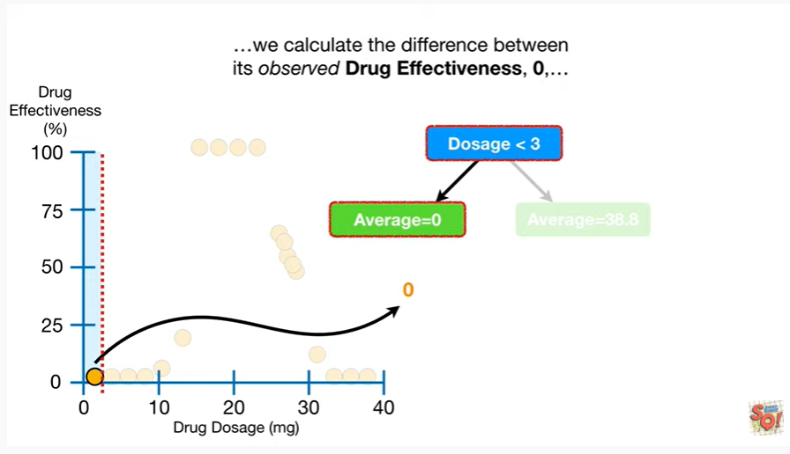

we calculate the difference between it's observed drug effectiveness, zero

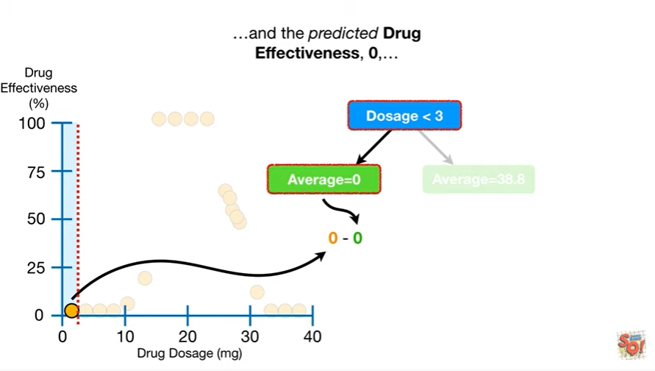

and the predicted drug effectiveness, zero

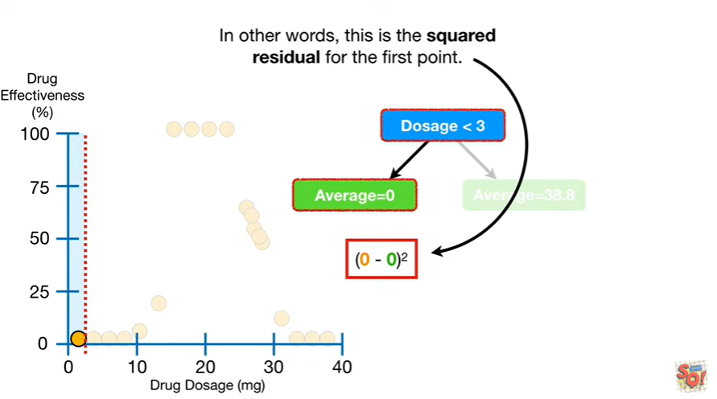

and then square the difference.

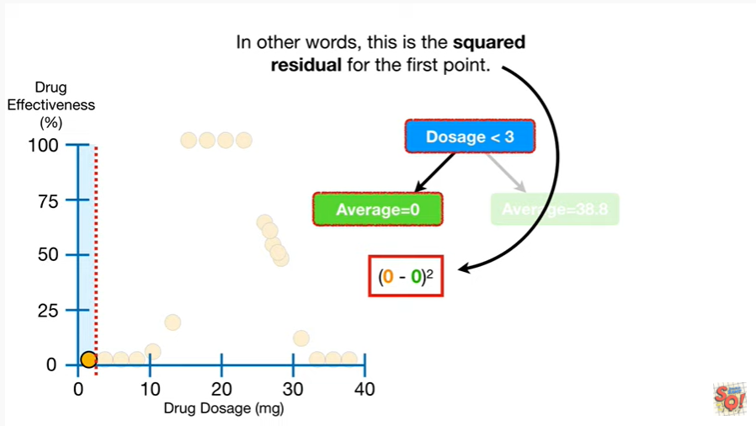

In other words this is the squared residual for the first point.

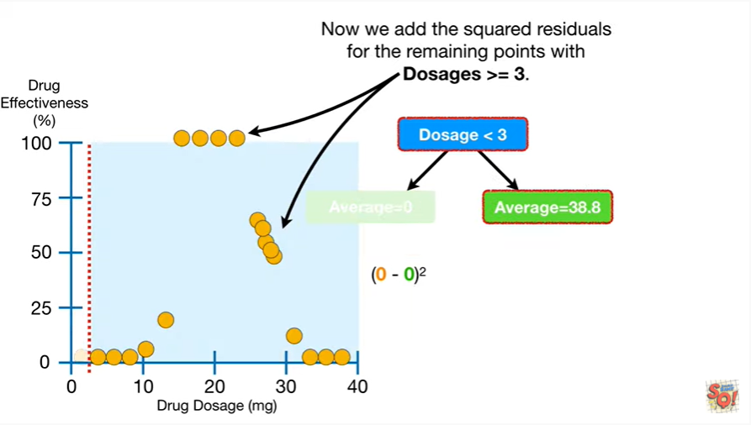

Now we add the square residuals for the remaining points with dosages greater than or equal to three.

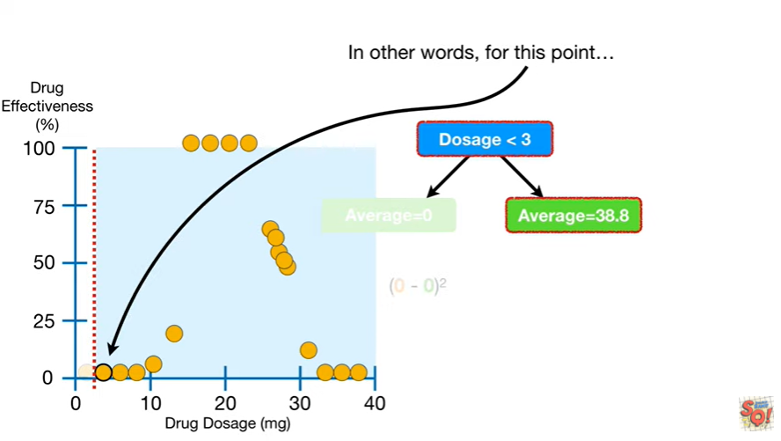

In other words for this point

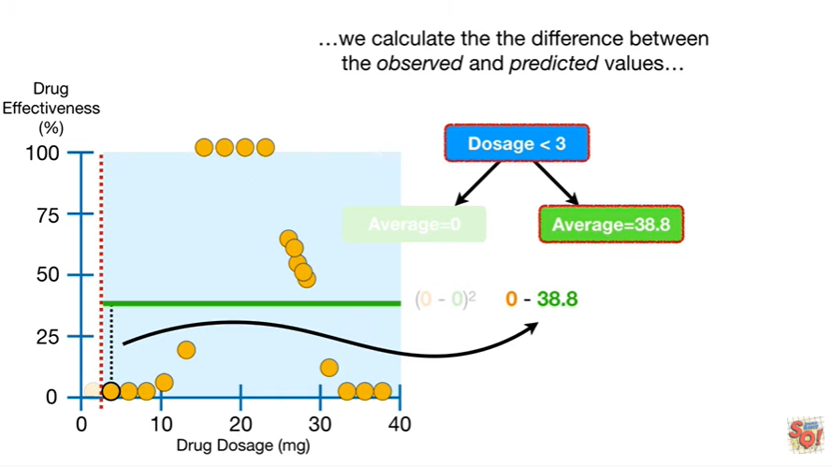

we calculate the difference between the observed and predicted values

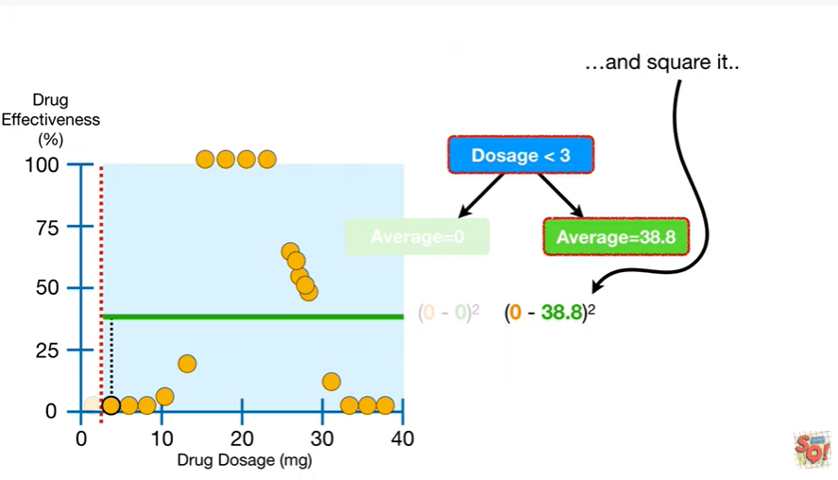

and square it

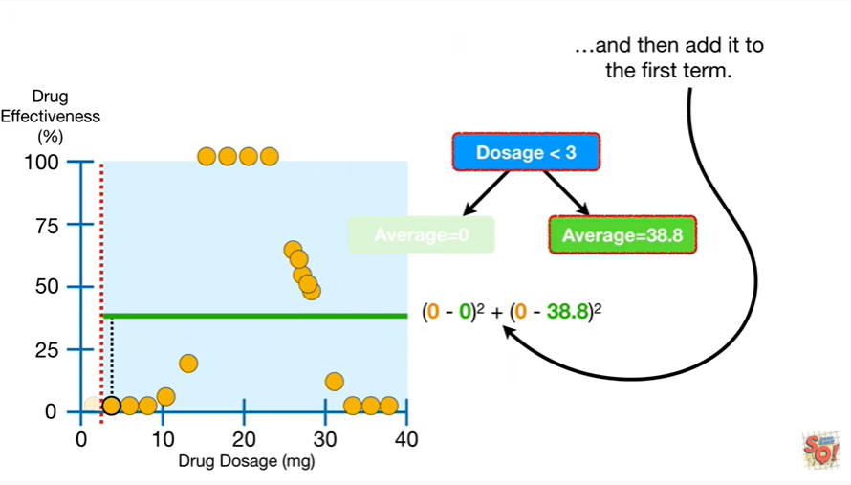

and then add it to the first term

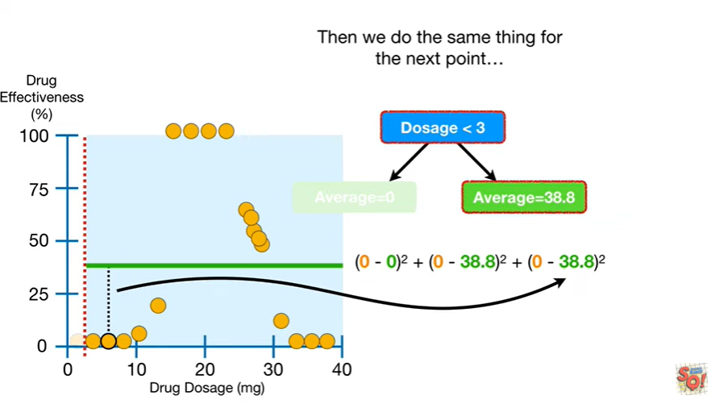

then we do the same thing for the next point

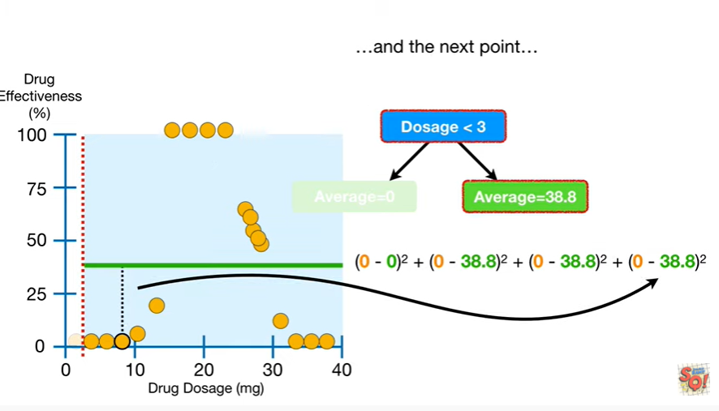

and the next point

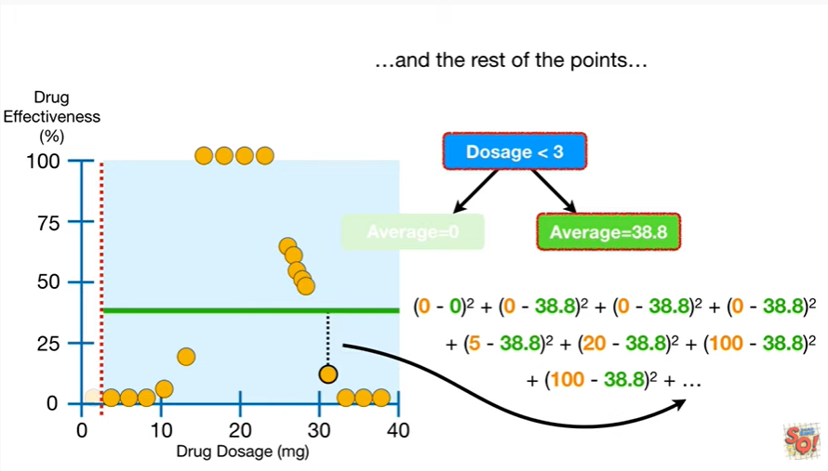

and the rest of the points do - ii ii ii ii ii ii ii ii ii ii ii ii ii ii ii ii ii

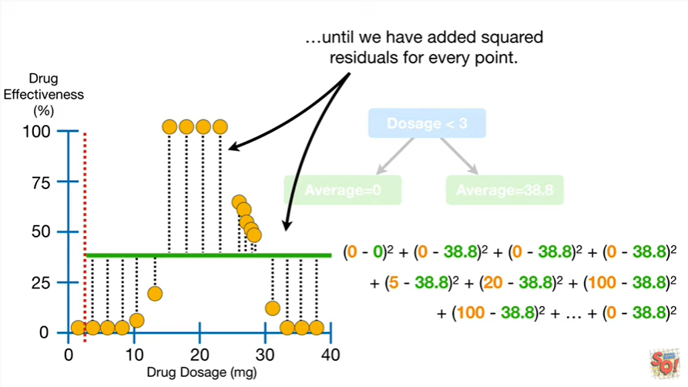

until we have added squared residuals for every point.

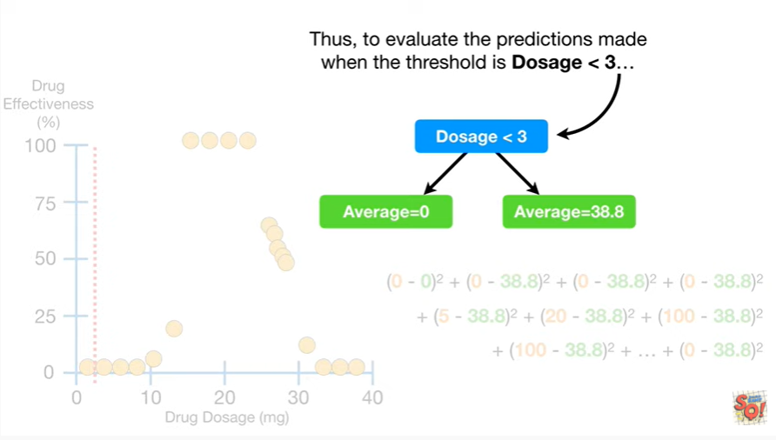

Thus to evaluate the predictions made when the threshold is dosage less than three

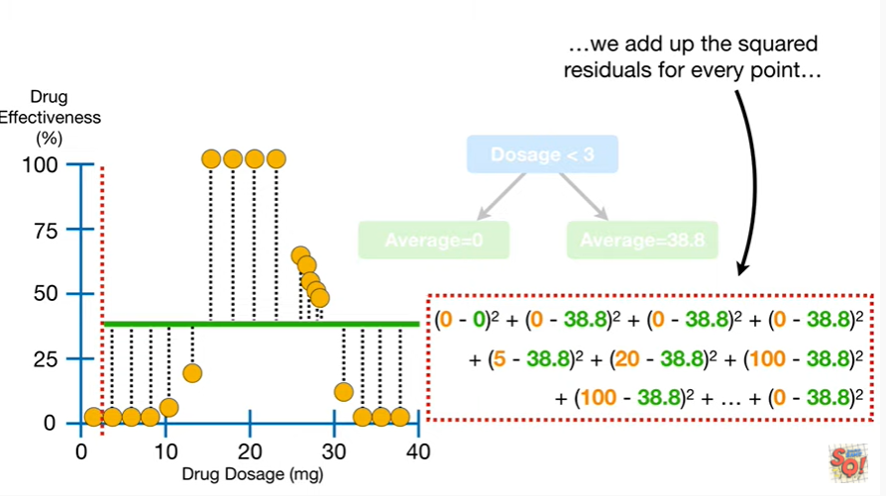

we add up the squared residuals for every point

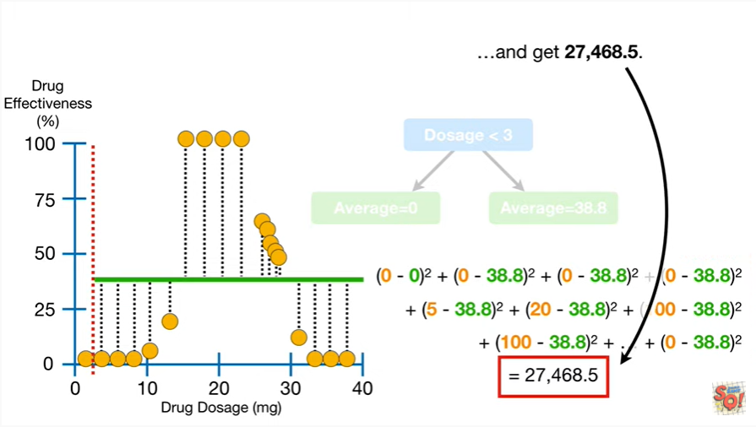

and get twenty seven thousand four hundred sixty eight point five.

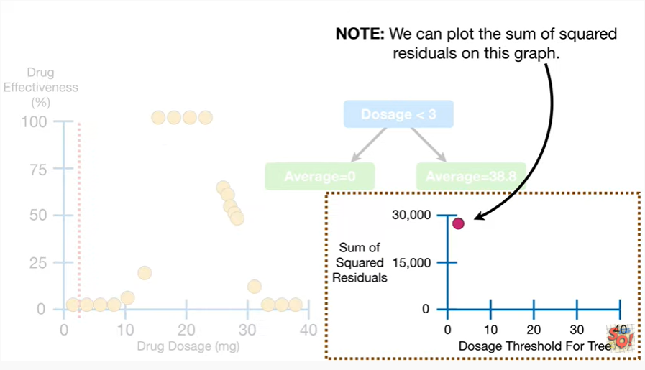

Note : we can plot the sum of squared residuals on this graph.

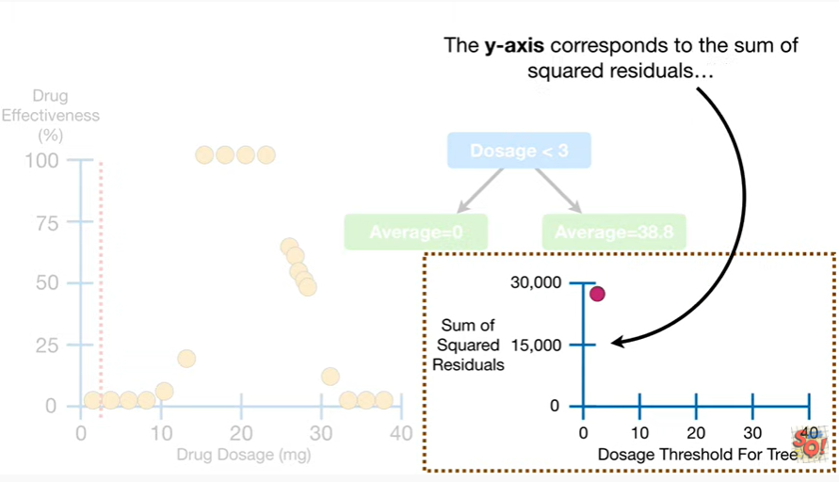

The y axis corresponds to the sum of squared residuals

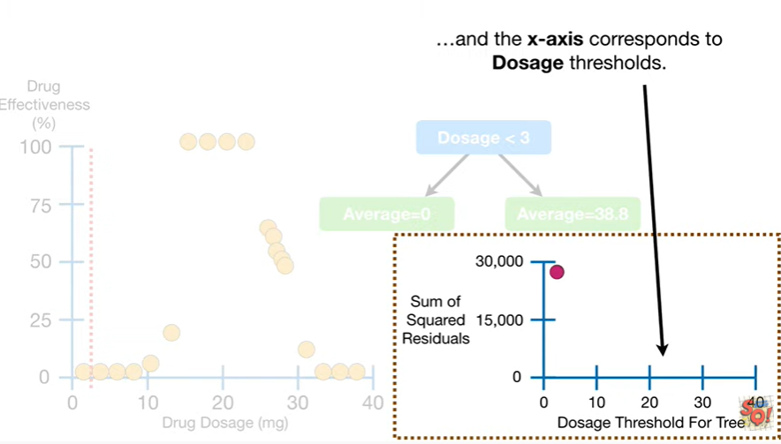

and the x axis corresponds to dosage thresholds.

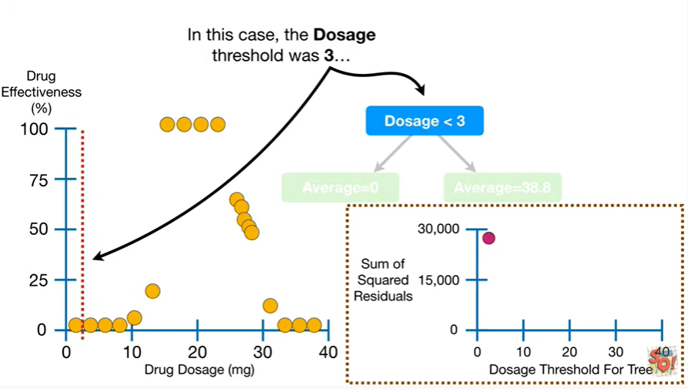

In this case, the dosage threshold was three

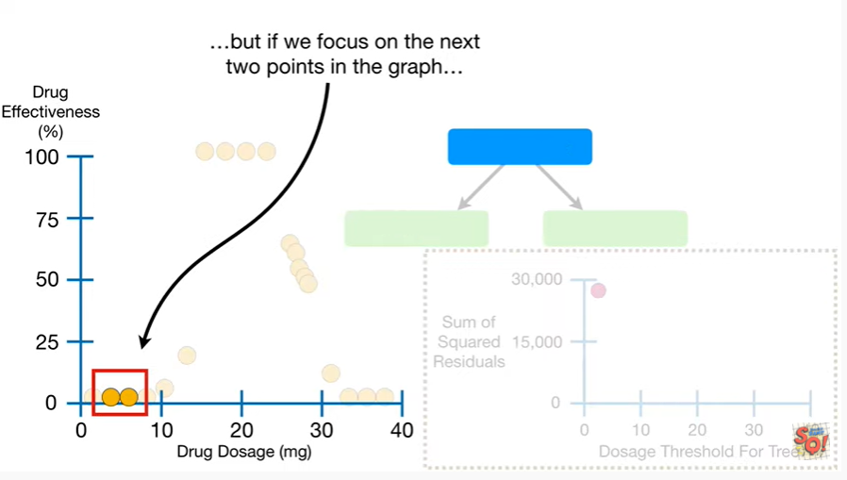

but if we focus on the next two points in the graph

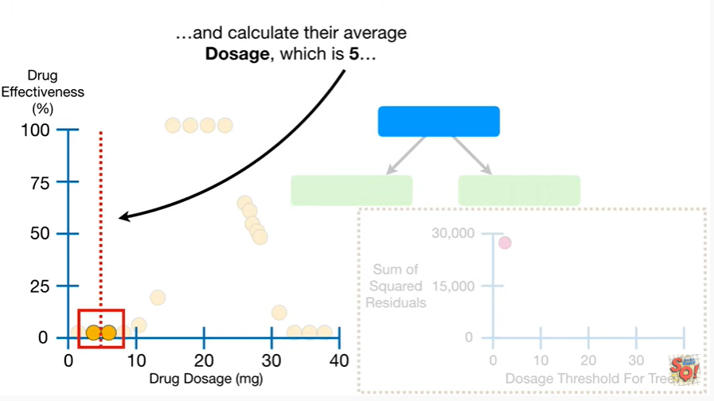

and calculate their average dosage which is five

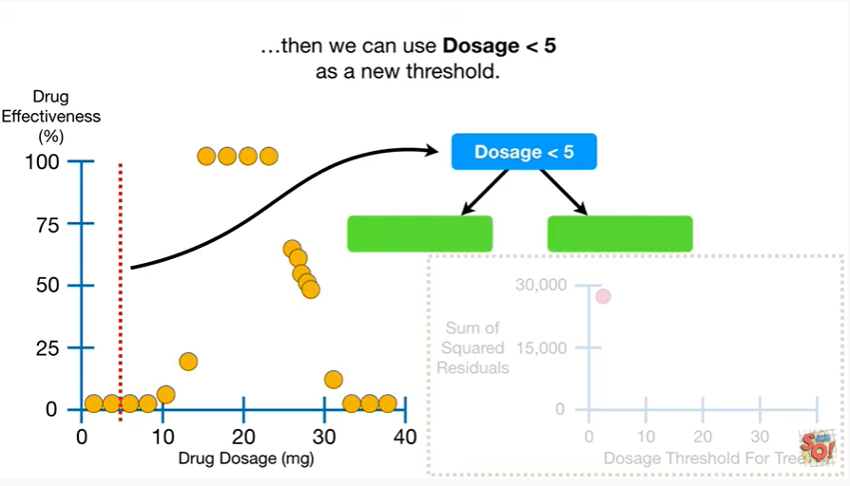

then we can use dosage less than five as a new threshold

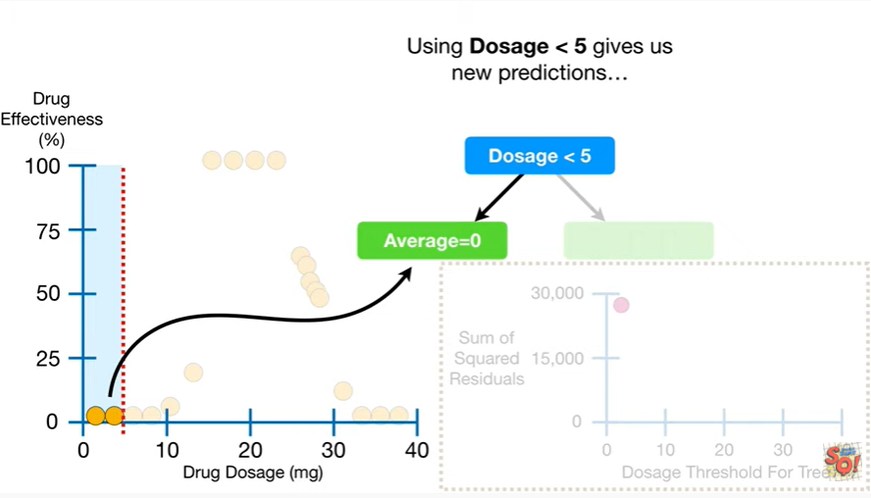

and using dosage less than five gives us new predictions

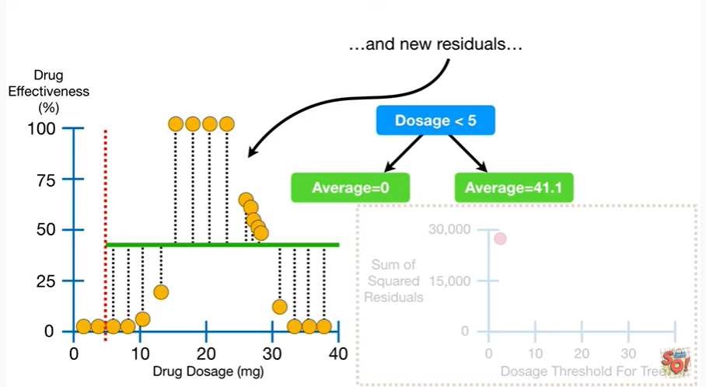

and new residuals

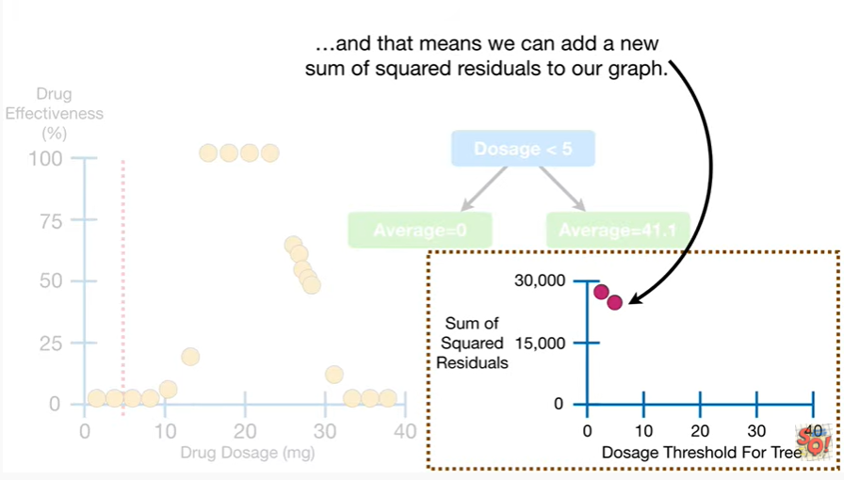

and that means we can add a new sum of squared residuals to our graph.

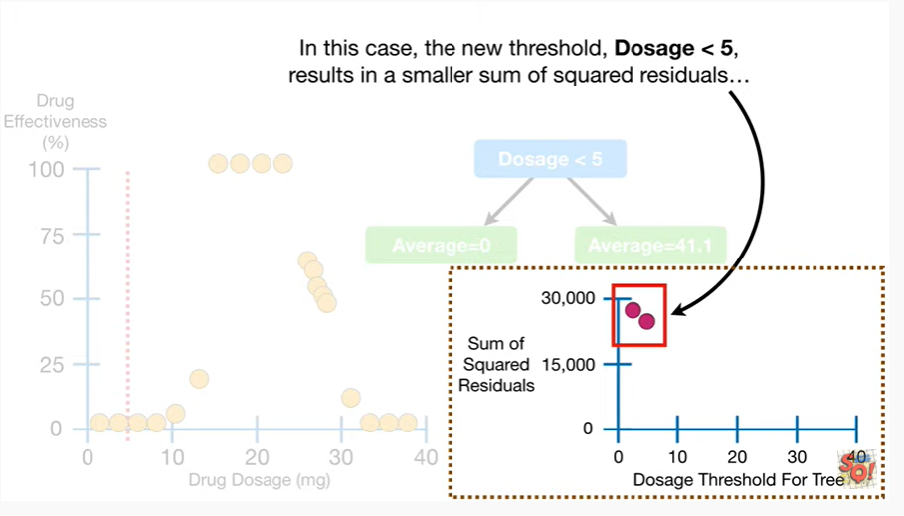

In this case, the new threshold, dosage less than five, results in a smaller sum of squared residuals

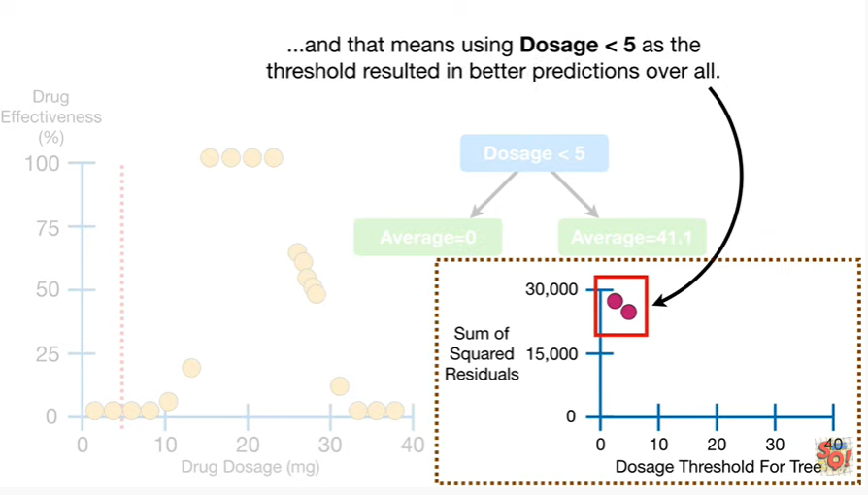

and that means using dosage less than five as the threshold resulted in better predictions overall.

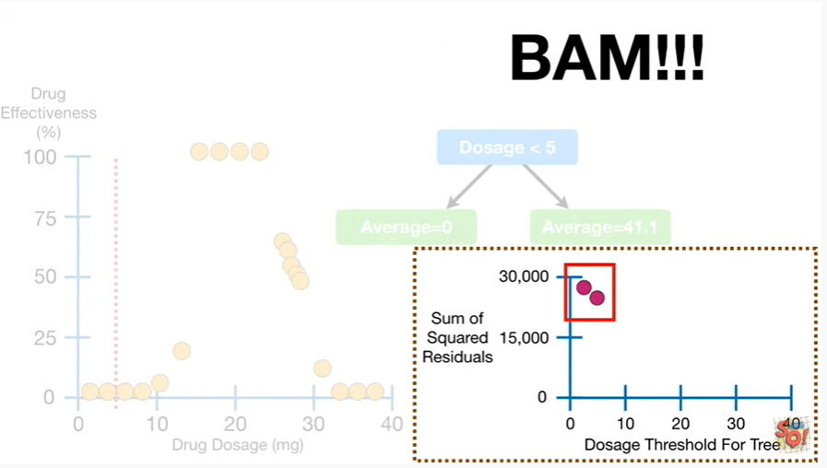 BAM !!!